**Lecture notes**

Structure of Course:

1. Introduce 1 or 2 problems and we will try to solve them together using algorithms. They are problem structures similar to a large number of problems with different variations.
2. We will come up with general techniques/paradigms so that we can solve the problems and not use a brute force approach.
3. Useful in life 🥳
4. Goal: To learn (weee!)

# 1/8/2024 (W1: Monday)

Lec 1: <https://youtu.be/zhnYy4xxUG0>

Design and analysis of **algorithms:** method of solving a problem,

* comes from persian mathematician, Al Karezmi, who did mathematical astronomy

Design

* Need to come up with methods
* Understand which design is the best, why we are using a certain method
* Is it possible to improve the methodology?
* Understanding a systematic approach
* General methodology which can be applied to general problems
* 5-6 paradigms we will learn, and we will solve problems using these paradigms

Analysis

* Mathematically find the power consumption, memory usage of algo
* How good is the algorithm? Can we improve it? Is there a lower bound?
* Collection of problems

*Course objective: Design algorithms for problems and analyze. Most of our analysis will be time complexity.*

Once you have a model of computation, we won’t worry about the tech changes. Come up with a model so that we need not change the algorithms with tech advancements.

Problem 1:

(Matching) When we have two group like this:  
A (students) B (medical schools)

1 a

2 b

3 c

. .

. .

N #

Both with N elements each. *(This algo is being used to match students to med schools)*

Each student must strictly rank each medical school and each medical school has to strictly rank students. One must give a complete ranking and must be willing to go to any of the med schools. Same goes for the med schools. Med school must take the student if the algorithm decides so. It’s a complete ranking.

Like,

A (students) B (medical schools)

1 (a, c, b) a (2,1,3)

2 (c, b, a) b (3,2,1)

3 (a, c, b) c (2,1,3)

**Problem Statement**

1. **We have N students and N med schools, both ranking each other strictly and completely and we need to find a stable matching.**

We are interested in **stable match**:

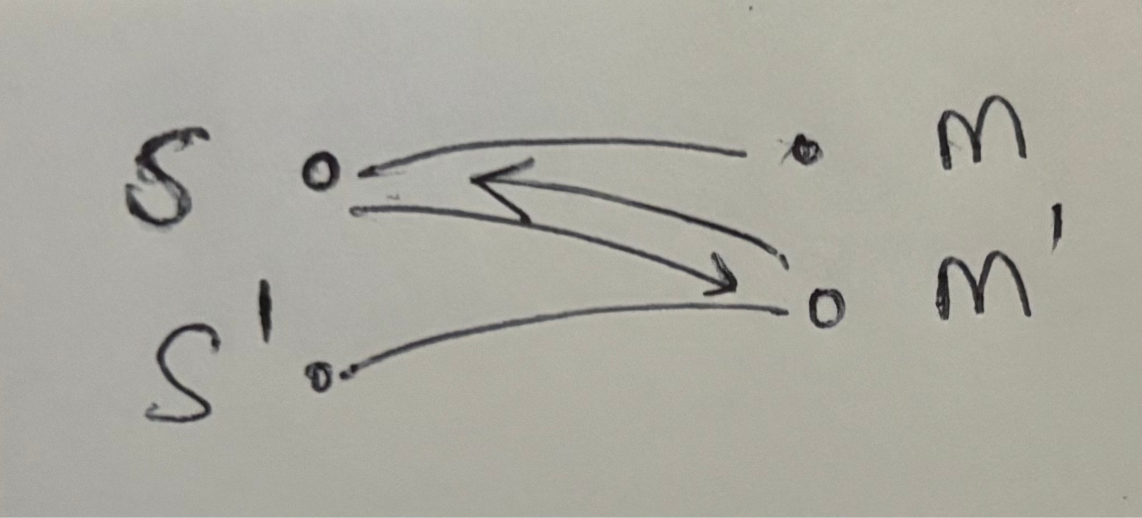

But S prefers M’ over M

**And** also M’ prefers S over S’

This is an **unstable match**. If we observe this pattern anywhere in the solution, then that is an unstable solution because let S match to M’ and let M’ match to S.

If this is:  
But S prefers M’ over M

**Or** also M’ prefers S over S’

This is **not an unstable match**.

Thought Process 1:  
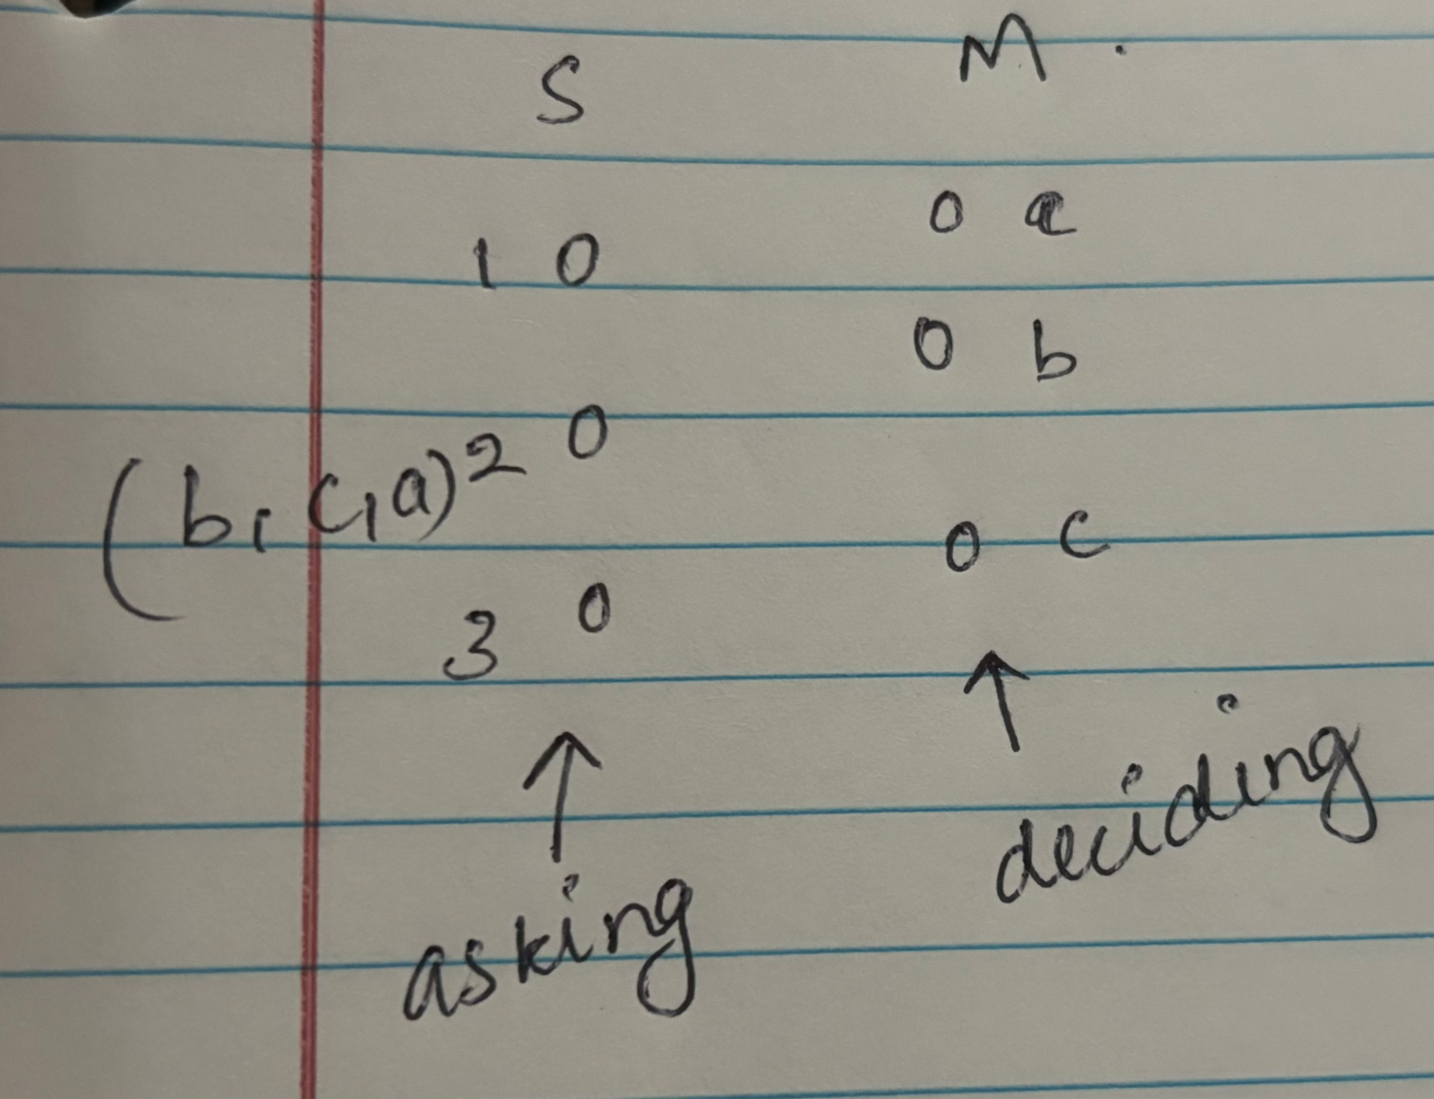

First we are focusing on the students.

1. Pick an arbitrary unmatched student, say 2
   1. *We don’t pick randomly because that's expensive and beyond the course*
2. 2 will pick the highest med school according to their rankings, that it has not picked before

**Case 1:**

1. 2 will say I will b, and if b has no match it will accept 2

**Case 2:**

1. If b has a match, b matches with 2 if 2 is higher ranked than 3. So b may either change it’s preference or stay, depending on it’s preference between 2 and it’s current match

Steps 1- 4 is called one iteration. After each iteration, one of the med schools will be crossed off and a particular will not ask that med school again. Since we have N schools and N students, there are possible $N^{2}$ medical schools permutations. Thus, the **algorithm terminates after $N^{2}$ steps.**

1. At the end, why do we even get matching, and not constantly have matching-unmatching with students?
2. Why is this a stable matching?

I claim that we get matching and stable matchings.

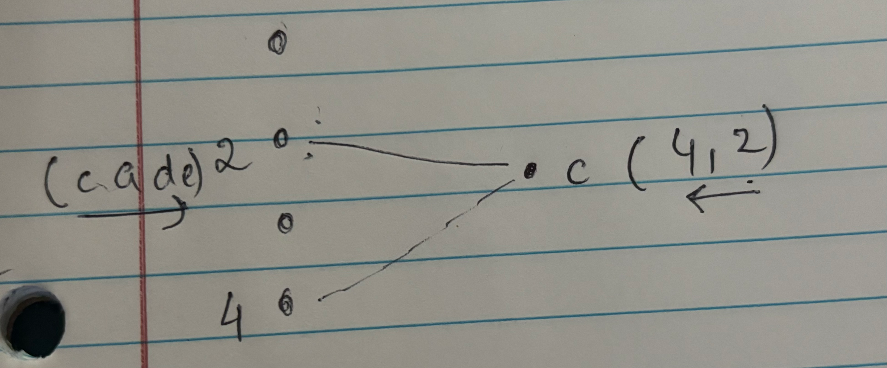

Property 1: *the matching of student gets worse in its own ranking with time, while for med schools with time it is getting better*

Property 2: *once a med school gets matched, it will stay matched, while this is not true for the student.*

By Contradiction, (matching)

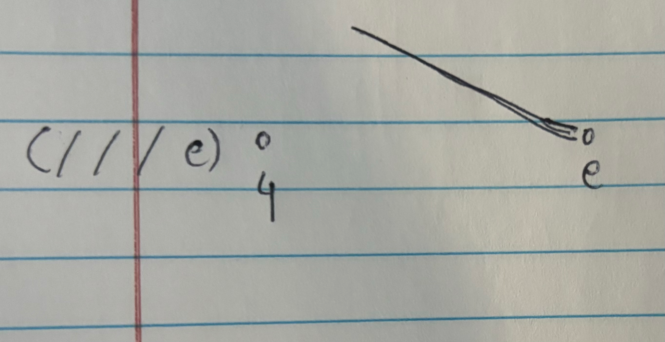

It’s impossible for a med school to be unmatched, and thus we will always have a one-to-one matching

By Contradiction, (stability)

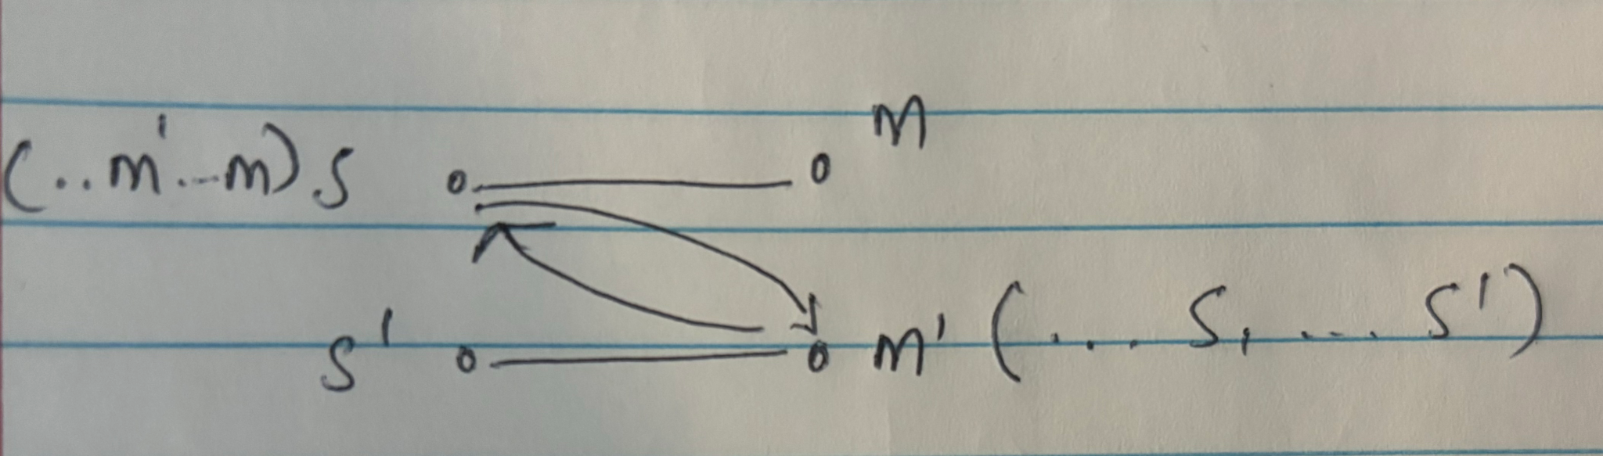

Assume that our algorithm makes this shape. S last proposal was to M.

Did S propose to M’ at some point?

1. No: That is not how our algorithm works. [CONTRADICTION]

2. Yes: Means S was rejected by M’ at some point in favor of another student S’’. Means S < S’’ (lower ranked). If this is the case then M’ ranking is improving with time, and thus M’ cannot match with S’ as S’’ > S > S’. M won’t go with a lesser ranked student. [CONTRADICTION]

Thus what we have done:

1. Terminating algorithms: in $N^{2}$ **iterations** (upper bound)
   1. We need to show each iteration is done fast: Need to do a detailed data structure analysis to determine this.
2. Matching
3. Stable Match
4. But is this a good algorithm?

A problem that never terminates is the halting algorithm.

* Upper bound: Basic algorithm
* Lower Bound: No one can do this faster

# 1/10/2023 (W1: Wednesday)

Lec 2: <https://youtu.be/EQqd-KOGDU4>

**Computational Complexity - Order Notation**

* We can do an exact calculator regarding run time of an algorithm but it runs differently on different computers, very time consuming
* That’s why we introduce order complexity to approximate computation in a more structured manner
* **Order Notation:** O Notation
  + When we say that addition takes about 2 steps or 2n steps, this is not very clear.
  + Example 1: if we have a function that expresses the runtime of an algorithm and that runs in time two times n. Like if we are sorting n integers and the algorithm runs in **2n time, or 1.5n time or 6n time** →   
    Answer 1: we say they are roughly the same number
  + Example 2: if we have an algorithm that runs in $n^{2} time.$ Then if n = 1000, 2n = 2000 while $n^{2}$ = 1000000. The number 2 in the exponential slows down the algorithm, the multiplicative scalar like 2n does not slow down the algorithm as much. If we have an algorithms that run in $2^{n} or n!$ time → so slow that it is not acceptable, useless.
  + Mathematical Definition:   
    (Fig1)   
    1 and 2 have the same trend and growth → roughly in the same order   
    Function 3 is not in the same order as 1, or 2  
    Function 4 is also not in the same order as 1,2, or 3  
      
    We say that:

$T(n) = O(f(n))$

$∃c > 0, n_{0} ≥0$ $∀n ≥ n_{0}$

$T(n) ≤ c.f(n)$ → we can say that T(n) is order of f(n)

* + Means that for n < $n_{0}$, we don’t care about the time complexity of the algorithm. Algorithm design is for large values of n, and that’s what matters.
  + 2n and 3n are approximately the same: that's where the c comes into play, c must be a constant and that’s why we write T(n) = c.f(n) and not c(n). It should not be a function of n.
  + Example 3: T(n) = O(n^2)   
     this means that n $≤ cn^{2}$ → $n = O(n^{2})$

8n $≤ cn^{2}$ → $8n = O(n^{2})$ for c = 8,10,12

$4n^{2 }≤ c.n^{2}$ → $4n^{2 }$ = $O(n^{2})$ for c $≥4$

$\frac{n^{2}}{6}≤ cn^{2}$ → $\frac{n^{2}}{6}$ = $O(n^{2})$ for c $≥\frac{1}{6}$

All of the above is true by our definition.

* + Example 4:

$n^{3 }≤ cn^{2} ?$ No. $n^{3 }$ increases much more rapidly than $n^{2}$. Thus for large values of n, $n^{3 }$ is bigger $n^{2}$. Thus, $n^{3 }$ $≠O(n^{2})$ $2^{n} ≤ cn^{2}?$

No. Again, $2^{n}$ increases much more rapidly than $n^{2}$. Thus,

* + Example 5:

120log(n) $≤ cn^{2} ?$  
Yes. 120log(n) =

* + **O believes function less than or equal to, ignoring the constant, and can do better than that**
* The order notation that we discussed is useful for algorithm design and upper bound.
* Order notation can be used for memory usage, runtime, power consumption, anything, we care about runtime and time complexity and maybe memory.
* **Order Notation for Lower Bound** :   
  Fig2 insert
* Example 6: Fig3
* Omega notation is used to express the lower bound on a given problem, ignoring constants we only check how the function growth compares w.r.t. n .
* If $T(n) = O(f(n)) and T(n) =Ω(f(n)), then T(n) = θ(f(n))$

Example 7:

$2n^{2 }= θ(n^{2})$

$3n^{ }≠ θ(n^{2})$ → because although 3n is order of $n^{2}$ it is not Ω of $n^{2}$

$2^{n}≠ θ(n^{2})$ → is Ω of $n^{2}$ but not order of $n^{2}$

* When seeing order, omega or theta notation, the lower orders following the highest degree stop mattering, and we can do algorithm analysis using this

**Implementation of Stable Matching Algorithm**

* ***Look at Problem 1 from W1 Monday for reference***
* For every student there will be at most n asking and since there are at most n schools, the algorithm terminates in O ($n^{2}$) and it produces stable matching but I want to prove that all iterations occur in O(1)
* Step 1: showing that each student if it’s available can go to the next medical school, by implementing an array or linked list. O(1)
* Step 2: of all these students which are free? Maintain a list of free student, then find a free student O(1) which may be matched to a medical school or not → either the free student list will remain unchanged or it will replace the unmatched student with another student that the unmatched student knocked off
* Step 3: If 2 is asking to be matched with school d, and determine the rank between say student 4 and 2, and determine which it wants to keep. This takes O(n)
* Now notice Step1 = O(1), Step2 = O(1), Step3 = O(n) → Algo = O(n^3).
* How to do Step3 faster? Make a pre-computation rankings array and compare their rankings, and not dynamically calculate it → **Thus Step1 = O(1), Step2 = O(1), Step3 = O(1) → Algo = O(n^2).**

**Model of Computation**

* We need to come up with a **Universal Model of Computation:** has to be simple enough, but not too simple that it does not represent the general computer
* One of these models is called the **Serial Model of Computation**:
  + one processor, or 2,3,4, not infinite
  + Also called Van Neumann model of computation
  + Assumptions:
    - You have an ALU - can do basic ops like multiplication, add, bitwise, shift left, comparisons, etc. and can be done roughly in some time, say O(1)
    - We also have a collection of registers, 16, 32, 64, constant, and writing and reading from it is O(1) time
    - We assume we can do input and output O(1) time
    - Infinitely large external memory, and writing and reading from it O(1) time
  + Was found to be fairly accurate and still is, and was used for design of algos
  + 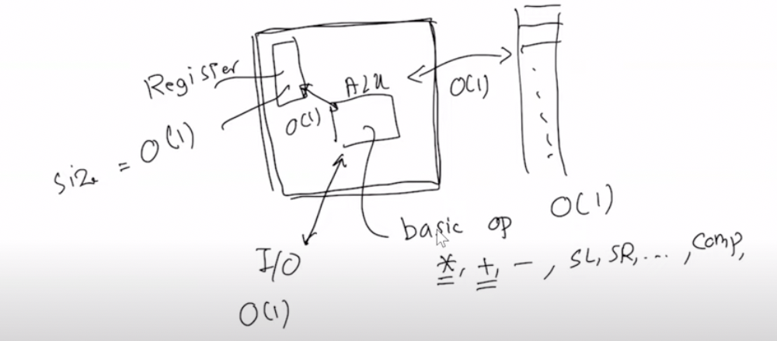
  + Example 8: How long does it take to compute the sum of n numbers by the Serial Computation Model?
  + Step 1: we have to read n numbers by input so that would be O(n) and again to read to big main memory O(n). O(n) + O(n) = O(n)
  + Step 2: Now we have to take the numbers and add them one by one, so reading from the big main memory is O(n) and adding by ALU is O(n-1) thus total is O(n)
  + Step 3: Outputting is O(1)
  + Total = O(n) + O(n) + O(n-1) + O(n) + O(1) = O(n)

*In this course we will assume to be using the Serial Model of Computation and the Asymptotic Algorithm Analysis*

Problem 2: (famous problem) A person in a group of n people is called “famous” if everyone knows the person and this person does not know anyone. Properties: there could be no famous person, and there can be never be two famous people in a group

Example for Problem 2: like if there is a group of three people, (a,b,c) → a is famous if b and c know a, but a does not b or c

Answer: Step 1: Candidate Selection

The key to efficiently finding famous people is to realize that we can pair up people and compare them to quickly eliminate non-famous candidates. Here's a more detailed breakdown:

Initialize a Candidate: We start by assuming the first person (let's call them person 0) is our famous candidate.

Iterate Through the Group: We compare our current candidate with every other person in the group one by one. For each comparison, there are two possible outcomes:

If the current candidate knows the other person, this means our candidate cannot be famous (since the famous person knows nobody). Therefore, we switch our candidate to this other person because their being known by the current candidate suggests they are a better candidate for being famous.

If the current candidate does not know the other person, we keep our current candidate and move on. The other person cannot be famous because the famous person is known by everyone, and our candidate does not know them.

Outcome: By the end of this process, we are left with one individual who potentially meets the criteria for being famous because, through our comparisons, we've eliminated everyone who either knows someone or is not known by the candidate.

Step 2: Verification

Having identified a potential famous person, we must confirm they satisfy both conditions of fame: being known by everyone and knowing no one.

Verify Everyone Knows the Candidate: We iterate through every person in the group (except the candidate) and check if each person knows the candidate. This ensures the candidate is known by the entire group. If we find even one person who does not know the candidate, our candidate cannot be famous, and we conclude there is no famous person in the group.

Verify the Candidate Knows No One: Similarly, we check if the candidate knows any of the other people. We iterate through the group again (except the candidate) to ensure our candidate does not know anyone else. If we find that the candidate knows someone, they cannot be famous, as the famous person knows nobody.

If the candidate passes both verification steps, they are indeed a famous person. If the candidate fails either step, there is no famous person in the group.

Time Complexity

The candidate selection process goes through the group once, giving us a time complexity of O(n).

The verification step requires checking all n−1 other people twice (once to see if the candidate knows them and once to see if they know the candidate), also yielding a time complexity of O(n).

Thus, the overall time complexity of the algorithm is O(n), making it an efficient solution for finding the famous person in a group.

# 1/17/2024 (W2: Wednesday)

**Heap Data Structure**

* It's a data structure where you can put n elements, and you can quickly retrieve min value. O(1) time
* It’s a binary tree, with every root smaller than its children. This way we can retrieve minimum value as we can always have a pointer at the root.
* We can **heapify** after extracting the minimum
  + Heapify means to restructure the tree after removing the minimum
  + We take the minimum of the children and replace it on root

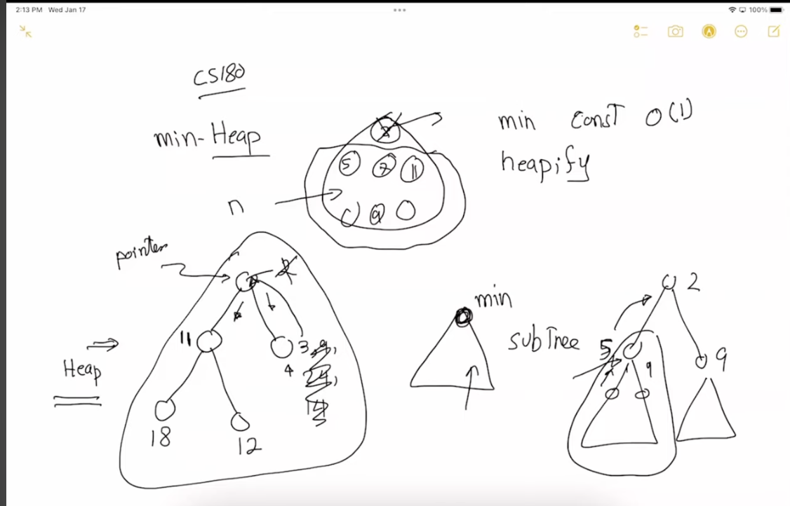

* + Recursively travel down the tree, and keep updating the parents for the minimum of children until root is reached
  + After removing the last element there might be a case that the child is smaller than the parent, and then we will have to go all the way up the tree
  + For balanced tree: O(log_2n)
  + Total removal: O(1)+O(logn) = O(logn) very efficient!! Priority queue 🥳
* We can’t do min and max in the same heap

**Graphs**

* Set of vertices and edges, not necessarily the same number
* G(V, E)
  + V = {1,2,3…}
  + E = {(1,2), (3,4) …}
* **Connected**: can start from any vertex and end at any
* Connected graph can only have 1 **component**
* **Directed and Undirected**
* Concepts usually apply to both directed and undirected graphs
* **Neighbours**
* **Weighted edges** show priority of the edge

**Algorithm**

Let there be an undirected and unweighted graph like such:

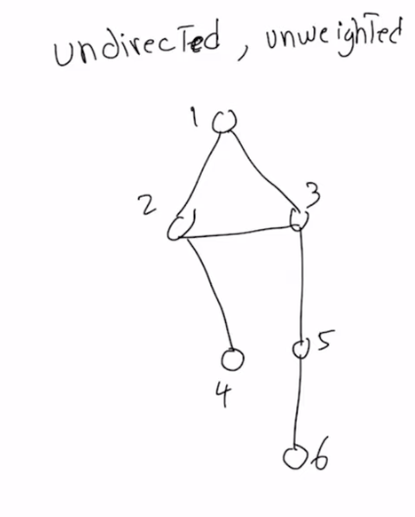

* Searching the graph
  + We have a starting vertex which is either given or we pick it arbitrarily
  + Say we start with 1.
  + We start with 1, and then search 2 and 3 simultaneously.
  + **Breadth First Search**: Search horizontally on the level then go down ([sahitigabrani@gmail.com](mailto:sahitigabrani@gmail.com): “bfs has structure”)
    - Breadth First Search tree: cannot be a cycle
    - 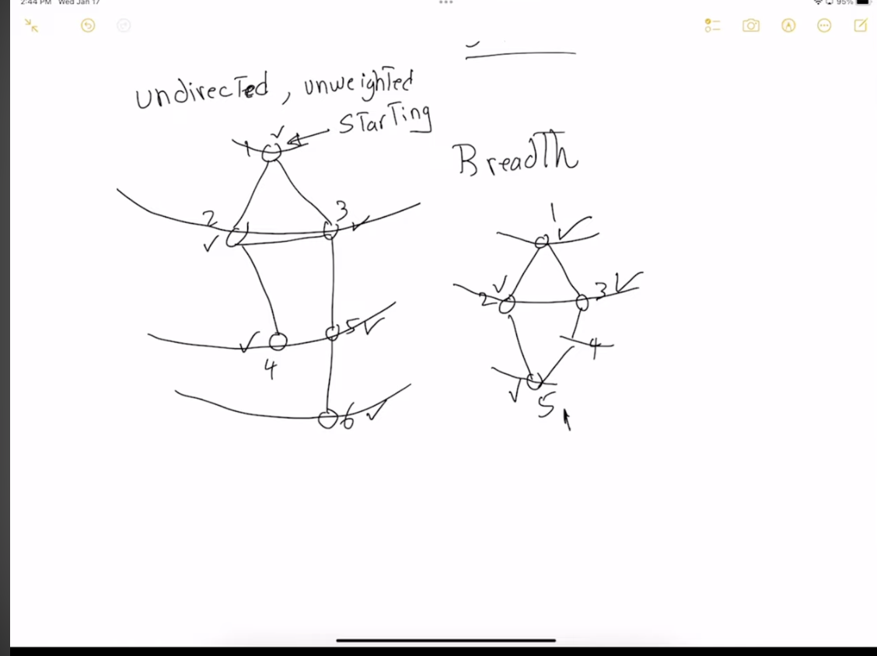
    - Question: Find the minimum path from a to x.  
      Claim: For each vertex we have a level number 𝓛(e). Level number of a vertex i, 𝓛(i) is the distance between a and i in G.   
      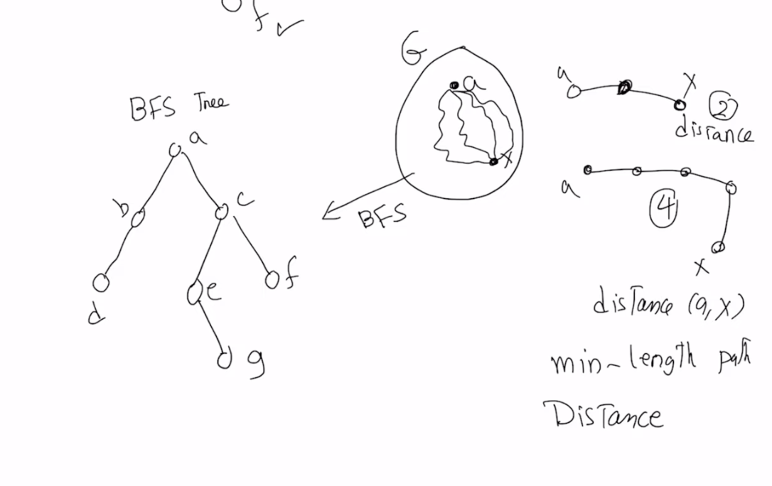
    - Proof:
      * Consider a vertex a and a vertex i, with the level number 𝓛(i).
      * We will prove this by contradiction. If the distance between d(a,i) is then it must be:
        + Case 1: d(a,i) < 𝓛(i)   
          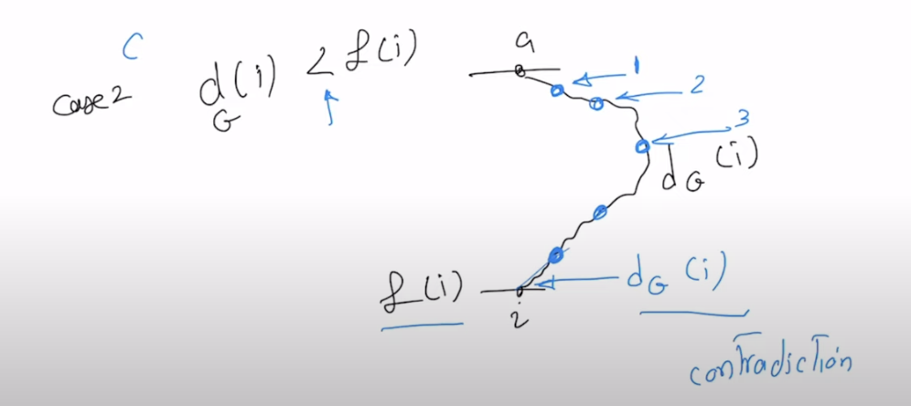

Now f we do BFS on the graph, we see that i can be reached by d(a,i), which is equal to the level of i, 𝓛(i), which means there’s a contradiction. Thus, this case cannot happen

* + - * + Case 2: d(a,i) > 𝓛(i)

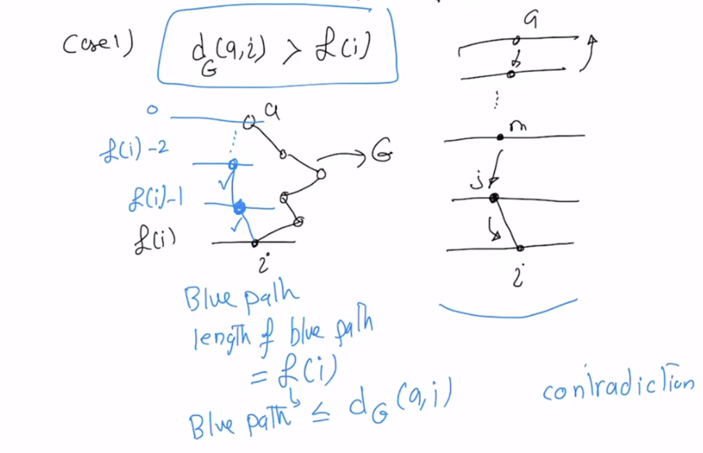

Suppose that the d(a,i) > 𝓛(i) , then the path in G must look like what it is on the left. Let’s look at i, reaching i from a through BFS, we have to traverse one vertex in the previous vertex. Traversing the blue path, we successively go back all the levels, and realize that length of blue path is 𝓛(i) and 𝓛(i) $≤$ d(a,i). Thus by contradiction of the initial assumption, this case is not possible.

* + - * + Thus, BFS can help find the distance between two vertices
        + Runtime Analysis:

The ways to define a graph are: Linked List and Matrix Implementation. 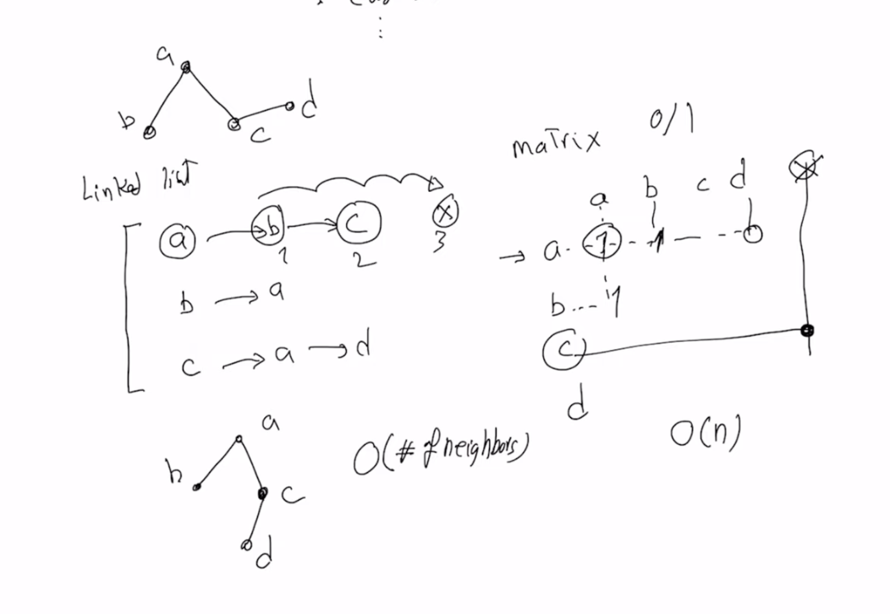

We visit an edge only twice for every breadth first search of a connected graph, once while we are seeing neighbors of say a, and once when we are looking at neighbors of b. In both these cases we will look at the edge (a,b).

If the number of edges in the graph is e, then the runtime order is 2e, O(e), if the graph is connected.

If the graph has components then runtime is O(e + # of jumps) = **O(E+N)** where N is the number of vertices.

Thus, we always use **O(E+N)** as the runtime of BFS because that’s the worst case scenario.

For a connected graph:  
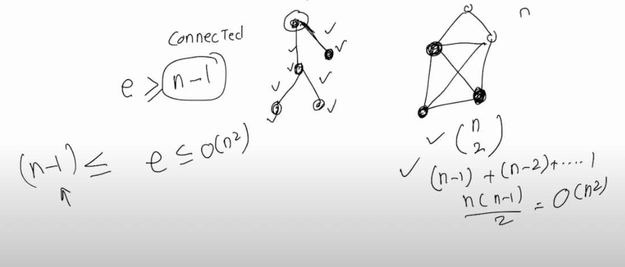

When e = n-1, we call the graph sparse. When e = O($n^{2}$) then we call the graph dense.

* + If a graph has cycles then its cyclic else it's a tree
  + **Depth First Search:**
    - [sahitigabrani@gmail.com](mailto:sahitigabrani@gmail.com): “jaha mera man kare mai jaunga”
    - 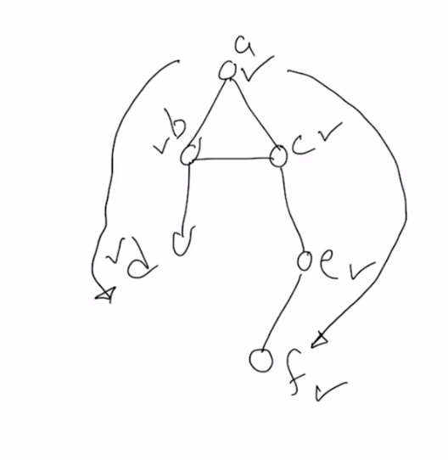
    - Analysis similar to BFS
    - Runtime: O(N+E)

# 1/22/2024 (W3: Monday)

**Breadth First Search:**

* Helps us to find the distance between any two vertices
* If the problem says find the distance between every pair of vertices, then we will run BFS for every vertex i.e. n times
* 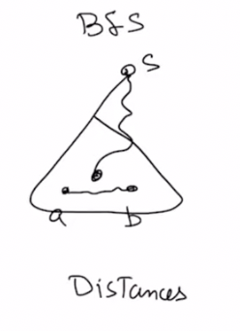
* Runtime: O(E+N)
* BFS can be thought of as a FIFO queue such that suppose we start with root s:
  + Then we explore its neighbors x, y and put in queue and pop s
  + Then we explore the neighbors of x, enqueue them and pop x,
  + And so on until the queue is empty which means all the nodes have been explored
  + 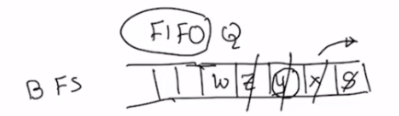

**Depth First Search:**

* Helps us to find cycles in a graph
* 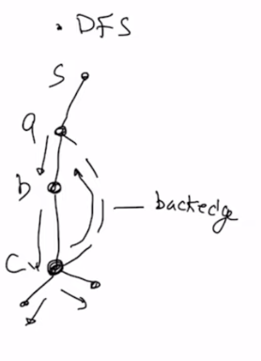
* Runtime: O(E+N)
* Works as a stack:

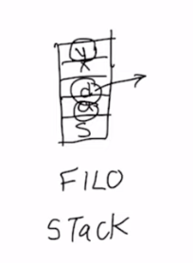

**Bipartite** Graph:

* 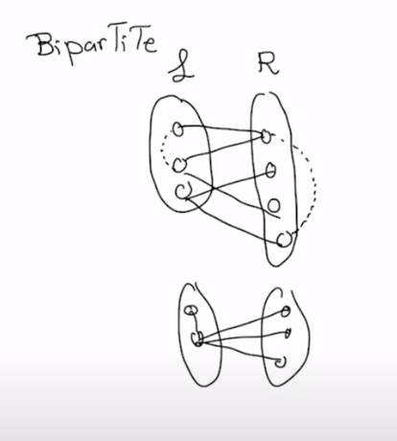
* A quadrilateral square is a bipartite graph. Works for all even.
* For n = 3, 5, odd..  
  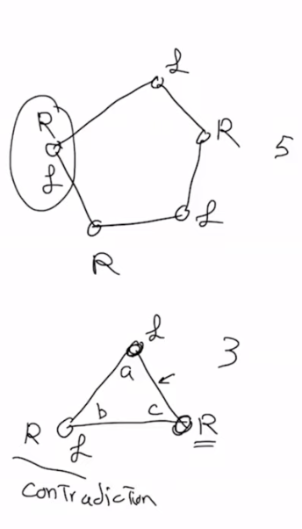
* Question: Consider a graph with vertices and edges G(V,E). Design an algorithm that decides if the graph is bipartite or not
  + Answer:   
    I claim a graph is bipartite if it does not have any odd cycles.
    - Work through all the nodes, one by one and add the node on L or R, and add it’s neighbors on the other side.
    - If the graph is unconnected, then we will add it arbitrarily on the L or R.
  + Runtime: disconnected graph: O(E+N) → linear in input size time, because we can have at most N jumps

connected graph: O(E) → no jumps

* Question: (**COLORABILITY**) if you have to color the nodes in two colors (like a map) but no adjacent edges can have the same color.
  + Answer: The same as bipartite graph
* Question: (**COLORABILITY**) if you have to color the nodes in three colors, then? Design the algorithm.
  + Answer:   
    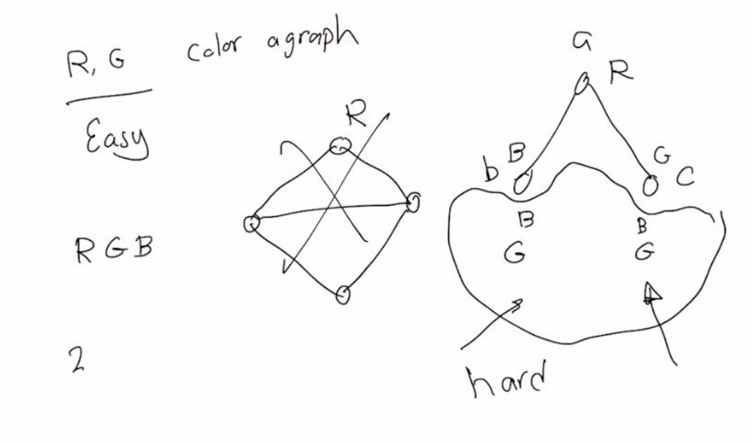

**Connectivity** of a Graph:

* If we can start from a vertex and visit all other vertices of a graph
* If it is not fully **connected**(undirected graphs) then, it has components that are connected
* To find the connected components, we run BFS without going to jump or getting stuck, it is connected
  + If we have to jump we can start counting a new component
  + If we have no edges then number of connected components is n
* **Algorithm:**
  + Use BFS, continue BFS, explore vertices
  + Every jump → new vertices and associate the new connected component with the new vertex
* **Strongly Connected (applies only to directed) Components**:
  + Two vertices are called to be strongly connected, if we via a bunch of edges go from a to b and from b to a.
  + If i can go any arbitrary vertex to any arbitrary vertex
  + **Algorithm** to check for strongly connected:
    - Take ${G and G^{r }where G^{r }is the reverse of G, edges-wise.}_{}$ Now to prove that G is strongly conneted, we will run BFS, and if every edge is reachable from every edge in both $G and G^{r }$ then we say the G is strongly connected.
    - Runtime: O(N+E)
    - LOOK AT THE BOOK
  + Question: Is this strongly connected?  
     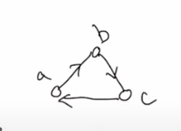
    - Answer: Yes
  + Question: Is this strongly connected?   
    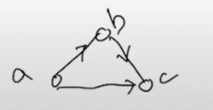
    - Answer: No. Cannot go from c to a in any way.

* **Transitivity of Connectedness:**  
  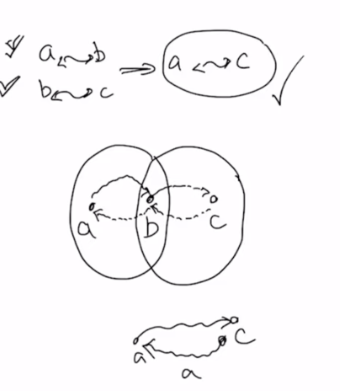
  + Strongly connected components will develop into a equivalence class
* **Articulation point:** 
  + Removal of the articulation point will split the graph from one connected component, to one or more.
  + 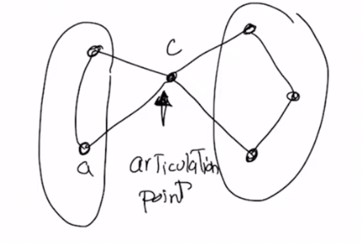
  + Question: find an algorithm to find the articulation point, it’s runtime
  + Question: find an algorithm to find the not articulation point, it’s runtime

# 1/24/2024 (W3: Wednesday)

**Sorting**

* Sort in a specific order: non-increasing or non-decreasing
* **Topological Sort:**
  + Only works for directed graphs, and acyclic graph (DAG)
  + What does it mean to sort a graph?
    - For a sorted graph nodes like this: x, _, y   
      Then there must not exist an edge from y → x
  + 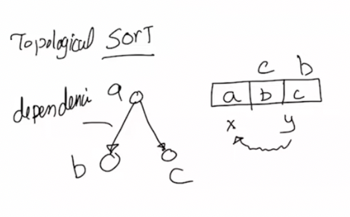
  + Topological sort is not unique
  + Any graph with a cycle of length i does not have a solution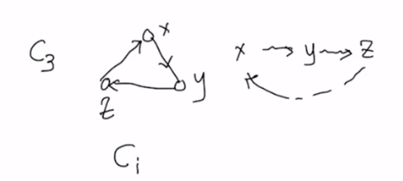
  + Question: Assume you have a DAG. Find the algorithm for the topological sorting of the graph.
    - Answer:
      * First define the in-degree of the vertex (all the edges that come into that vertex).
      * Consider a vertex with in-degree equal to 0 (sources).
        + How to find the indegree?

Initialize all the in-degree to 0.

Go to one edge of the graph, say (a,b). Then I go to vertex b and increment its in-degree by 1.

We can also calculate the outdegree in the same way without any additional cost.

Runtime: O(E) → to initialize all in degree

* + - * A DAG will always have at least one source vertex. A DAG can have more than one source.

Add the sources to a list (all nodes with in-degree 0). To find a source O(1), to output: O(1), to delete the source: , to reduce the edges coming out of the sources: n(number of sources)[n-1](the max number of edges) = O( $n^{2})$ (ACCOUNTING METHOD)

Instead of charging everything to vertices, we charge it to the edge: To find a source O(1), to output: O(1), reducing the in degree of the edge take O(1), and total runtime: O(e+1*n+1*n+e) = O(n+e), and if the graph is connected then O(e)

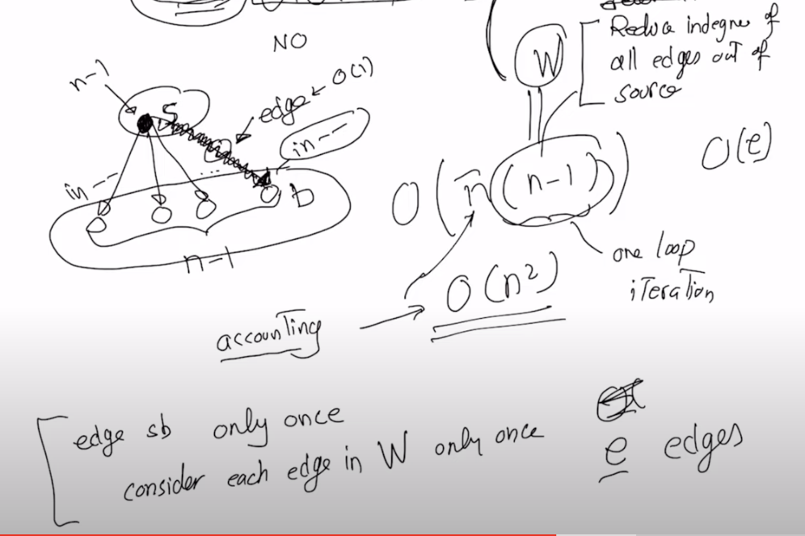

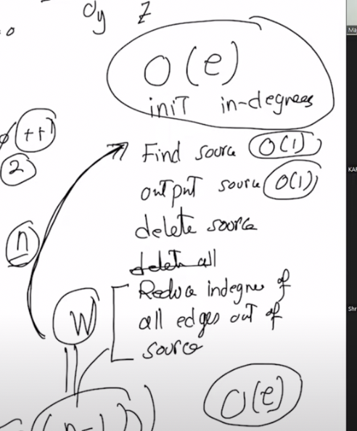

* + - * + Let’s start with a source *a*, and output *a*.
        + Delete the source *a*
        + Delete all the edges originating from source
        + Go to step 1 until there exists a source
        + 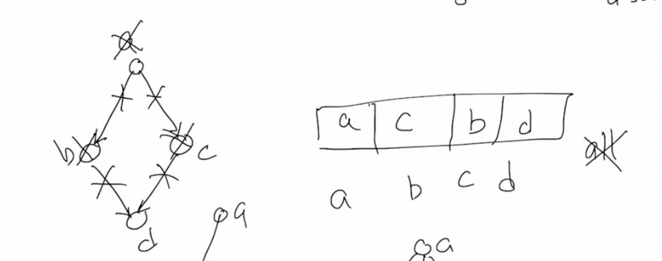
  + If a graph has cycles, then it cannot be topologically sorted, for example: 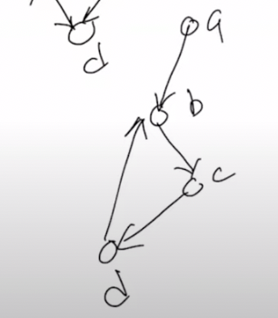

For this, we start with a, and delete all edges from a, but now we don't have any sources left, but we have not gone through all the vertices, which means that we have reached a cycle, and thus it cannot be topologically sorted

* + We can’t add cycles by removing the edges.

**Interval Scheduling**

* Question: We are given a set of intervals, could be time, there are n of arbitrary length. We have to find a maximum subset of non overlapping intervals.

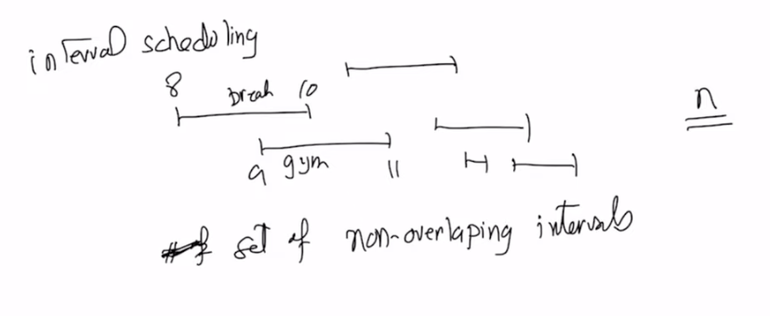

* Answer:   
  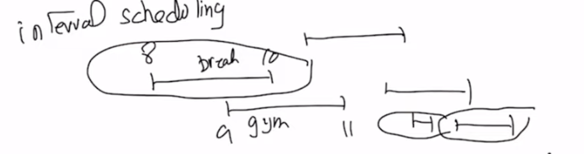
* **Greedy Algorithm:** 
  + Algorithm part1 (WRONG):
    - Look at all the parameters available to you, such as length
    - Find smallest (min length) interval
    - Delete all intervals overlapping it, and you continue this loop until no intervals are left.
    - Counterexample: 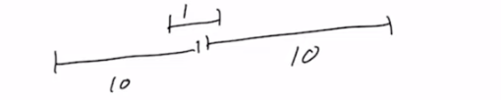
  + Possible parameters: length, number of overlaps, etc.
  + Algorithm part 2:
    - If we sort by ending point and pick the first interval
    - Now delete all the overlapping intervals
    - Proof:
    - Time complexity:
      * Sorting of intervals takes O(nlogn), and
      * then we do a linear scan of the list left to right, and an extra search for the last interval end time: O(n).
      * Total runtime: O(nlogn)

# 1/29/2024 (W4: Monday)

**Greedy Algorithm**:

* To make a quick and local solution, not a global solution
* One of the paradigms that helps us solve problems
* We find a parameter in the problem, and use that parameter to help us solve the problem

Question (SHORTEST PATH PROBLEM): find the shortest path

* For weighted graph: the smallest weight
  + 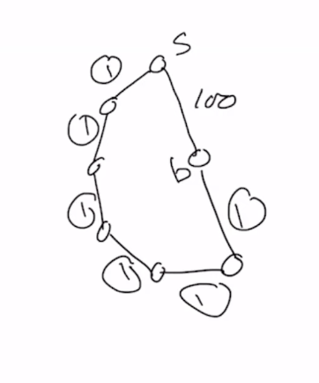 non-negative weights only

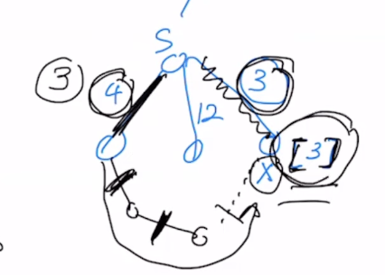

* + Notice that in this problem we blindly pick the vertex with the smallest weight, and we move to the smallest path, and then repeat for all of its neighbors. 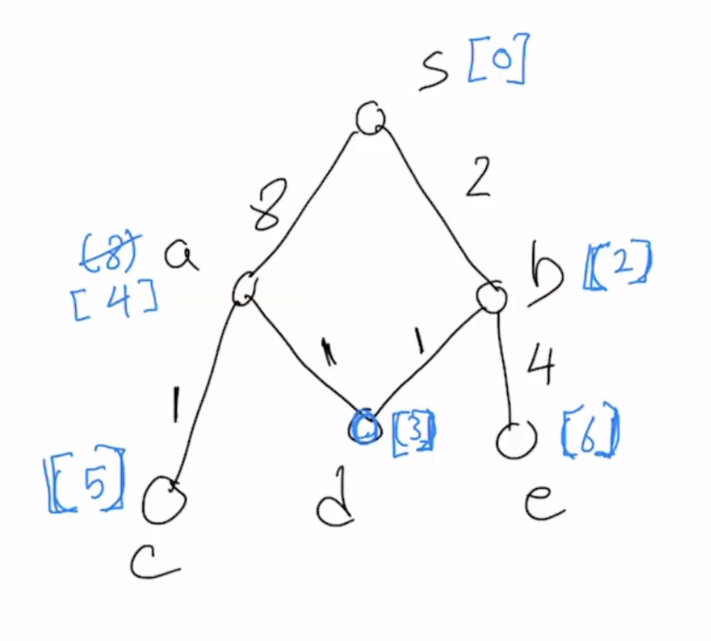
  + Time complexity:
    - O(elogn) using heap → adding all the edges to the heap and then finding the minimum of that two edges and adding to the top layer.This implementation is helpful when $e≤\frac{n^{2}}{log(n)}$ (sparse graph). More graphs are sparse.
    - O(n^2) → by adding vertices and edges to an array. This implementation when $e>\frac{n^{2}}{log(n)}$ (dense graph)
* Similarity between shortest path problem and interval scheduling is:
  + For both we picked one parameter, and we built our solution from there greedily. We did not look at the whole dataset but instead just at the one parameter.

# 1/31/2024 (W4: Wednesday)

Question: (Weighted Graphs) We have a graph with arbitrary weights, with distinct weights. They are positive.

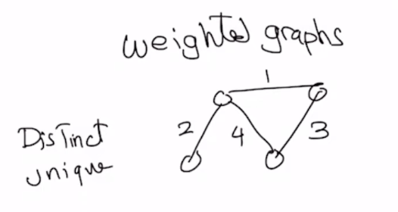

**Spanning Tree**

* Such a subgraph that connects all the vertices is called the **spanning tree**

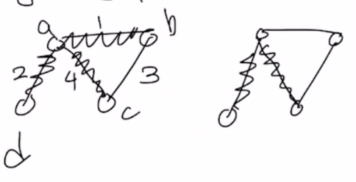

Left is spanning

Right is not spanning, as it does not touch all the vertices

* We are interested in **Minimum Spanning Tree**:
  + Sum of weights minimum

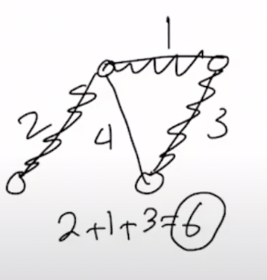

* + Always have n-1 number of edges
  + To find:
    - Exhaustive method:
      * Build every possible spanning tree and add each’s weights and find the minimum spanning tree.
      * Not relevant for algorithm design.
    - MST Theorem:
      * Consider a partition of vertices |V| into two groups, L and R, with both having a non-zero number of nodes

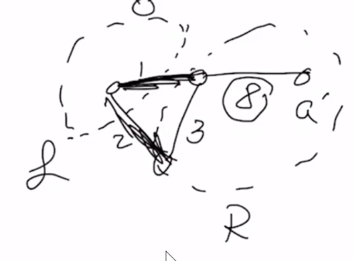

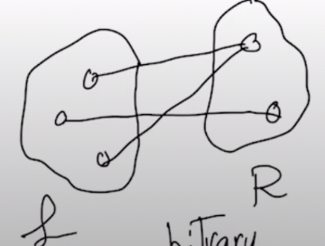

* + - * Let’s consider any arbitrary partition. Since we are using unique weights. There are many edges within L and R, and we only care about edges between L and R
      * Of all the edges, the one that has minimum weight ($e_{min})$
        + $e_{min}$ can change with partition
      * Claim: in all MST $e_{min}$ is included.
        + Proof by contradiction i.e. there exists at least one MST without $e_{min}$.
        + 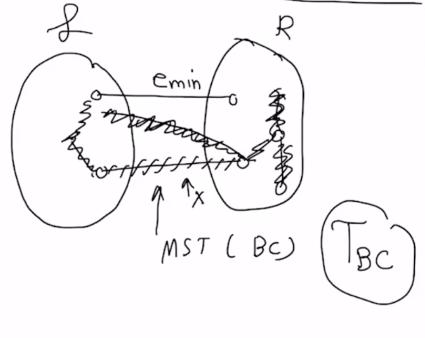
        + Notice that if I have a tree T, then (T+e) → cycle and **(T+e) - e’**, where e’ is an edge from the cycle that was created then, I get back a tree.
        + Now suppose, apart from $e_{min}$ there is an edge $e_{cut}$ that connects L and R.
        + $T_{BC}$ with total weight $W_{TBC}$ is the MST.
        + $T_{BC}$ ${ +e}_{min}$ ${ -e}_{cut}$ → new tree with weight $W_{new}$
        + Now as $e_{min}$ < $e_{cut}$ (as the edges are distinct) → $W_{new}$ < $W_{TBC}$. Thus, we have a contradiction as $T_{BC}$ was the MST.

**To Build MST**

* Prim’s Algorithm (GREEDY):
  + Also called vertex centric algorithm: move vertex one by one
  + Start a partition and put one vertex on one side, and all the other vertices on the other side.

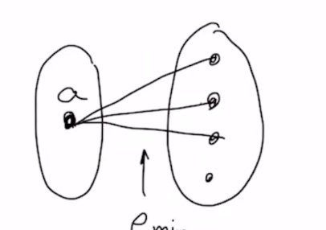

* + STEP 1: MST Theorem tells us to look at all the edges connected to a, and pick the minimum one, let it be $e_{min}$.
  + STEP 2: Now move the vertex to the left side: Next we pick the next $e_{min}$ and move the edge connecting b using $e_{min}$  
    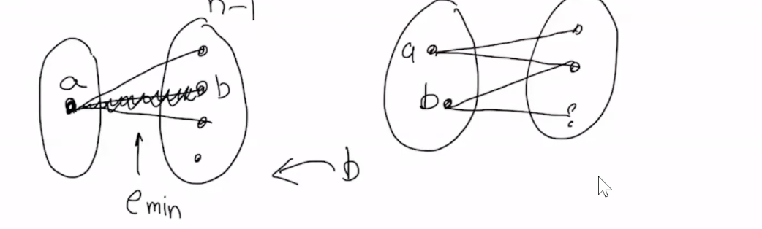
  + After all the steps, we build the MST on the L partition.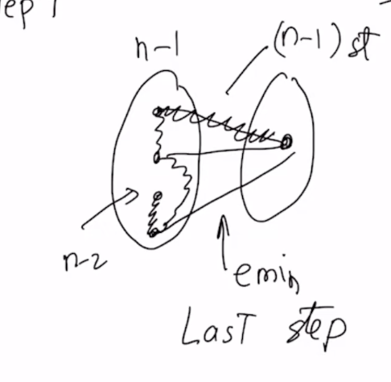
  + Runtime:
    - Left: I have a heap, with the minimum value of all the parentheses. The min value will always be at the root of the heap. O(logn)
    - Moving elements from right to left, i.e. including edges and heapifying that : O(logn) per edge
    - Total time to add weights and compare them: O(elogn)

**Question: Union-Find.**

* Find: We have a bunch of sets and we have to find a particular set, say (a,b). I say yes if (a,b) belong to the same set, and no if not. 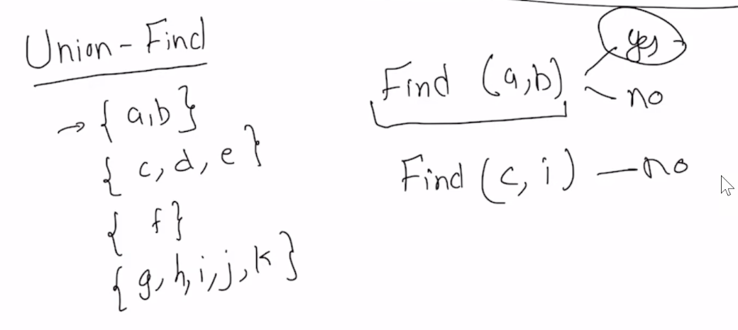
* Union: combine sets. So if I call union{1,3} = {a,b,f}, and get rid of sets 1 and 3
* Rooted Trees:
  + If $h_{1} < h_{2} or h_{2}<h_{1}$:
    - smaller tree points to the bigger tree
    - O(logn) → total number of nodes.
    - The height will be the larger ones.
  + If they have the same height then the total height will be $h_{1}+1$, number of elements = $2^{h_{1}}+2^{h_{1}}$.
  + Thus, h = O(logn)
  + Thus, trees like this cannot happen: These trees with h close to n will slow down the algorithm  
    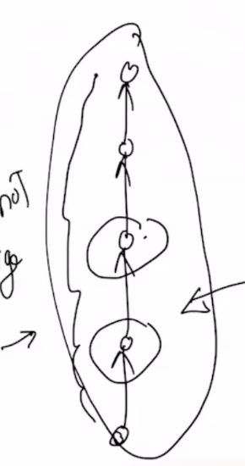
  + Trees are built like this:   
    
  + Theorem: For any tree that I build its height is O(logn). This means Find will take O(log n) and Union will take O(1)

**Kruskal’s Algorithm for MST**

* Sort the edges by weight, $e_{1}, e_{2}, ...$
* $e_{1}$ will be part of MST for sure.   
  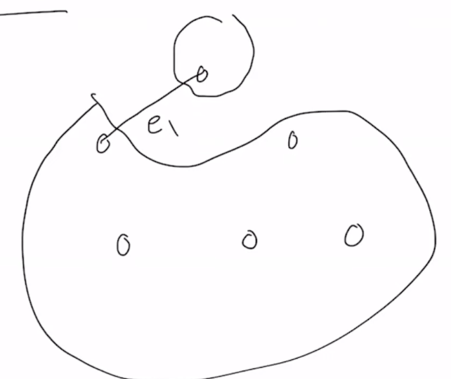
* $e_{2}$ will also be part of MST
* ${If e}_{3} forms a cycle with e_{1 }and e_{2}, then e_{3 }will not be in the MST, else it will be. Case for cycle:$ 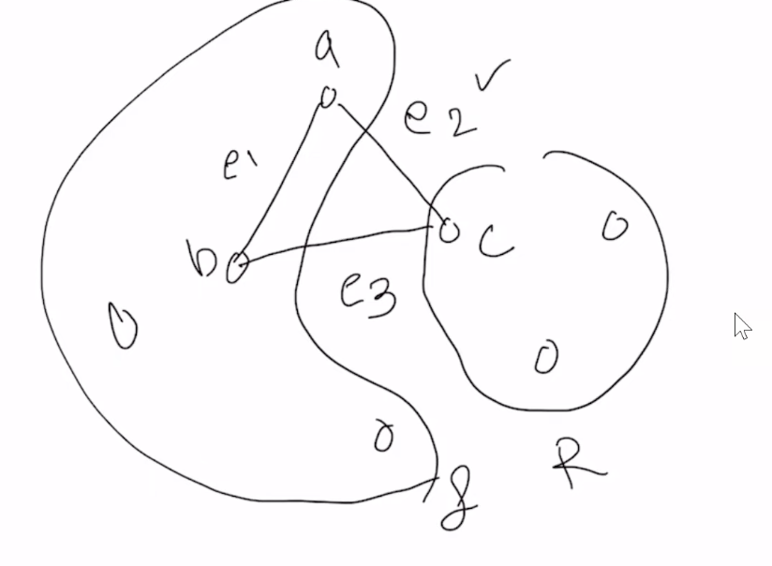
* For every edge, to check if it will be added to MST, we use Union Find to see if the edge forms a cycle or not. If it forms a cycle then we don’t add the edge, and if it does not form a cycle, then add the edge to the MST.  
   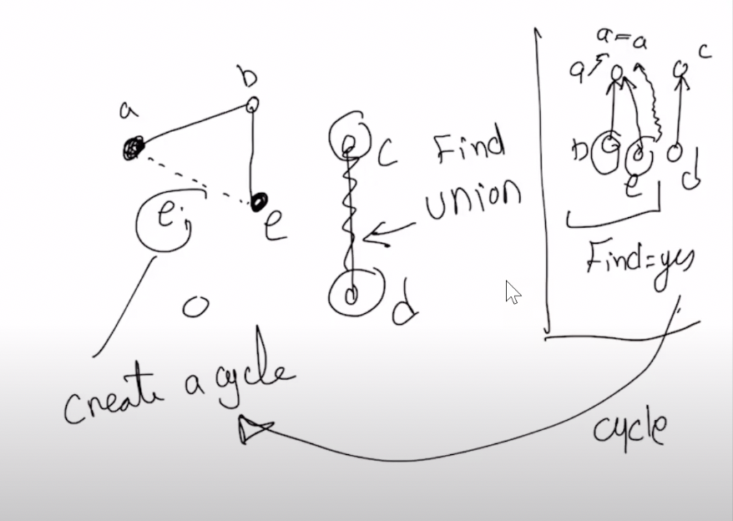
* Time complexity:
  + Sort the edges: O(eloge)
  + For each edge:
    - For each edge, we have to do a find: O(height of tree): O(logn)
    - If find says no, we add the node to the MST, then union: O(1)
    - Thus total for every edge is O(e(1+logn))
  + Total runtime: O(eloge)/O(elogn)
  + Best runtime: Ω(e)

# 2/5/2024 (W5: Monday)

Question: (**MAJORITY PROBLEM**) Say we have an array of an arbitrary number of candidates [a,b,c…].

Now say people vote in the way [b,b,a,b,c,b…]. We have *n* votes. We cannot assume that the number of candidates is constant in terms of n, it could be a function of n. A majority in the list of votes is someone who has >n/2 votes. Now, given a list of votes, how do you find the majority?

* There may not always be a majority. Ex: votes: [a,b]
* Can there be more than one majority? No

In general, there can be no majority or one majority.

Restriction: Array of votes of n elements given to us, and the extra storage given to us is constant.

Answer:

* FACT1: Suppose I have the array of votes [a,b,....]: if a was the majority and I deleted *a* & *any other vote*, then a will still be the majority in the (n-2) array.
* FACT2: If we did not have a majority, then by deleting two non-equal elements, we may create a majority. Ex: [a,b,c], and we delete a,b then we are left with [c] and we created the majority.
* Algorithm:
  + I take the n sized list of votes and start to delete two distinct elements, and I know that the majority still remains because of Fact1. I keep iteratively doing this until I am left with either [a], or [a,b] which is our base case.
    - Case 1: if left with [a], then a is a majority candidate
      * Now we go back to the og list and do a linear scan and count the number of a. If greater than n/2 it is the majority, else no. O(n)
    - Case 2: if [a,b] left, then we delete once more and are left with an empty list which means we don’t have a majority.
    - Case 3: if [a,a,a,..] then a is majority. 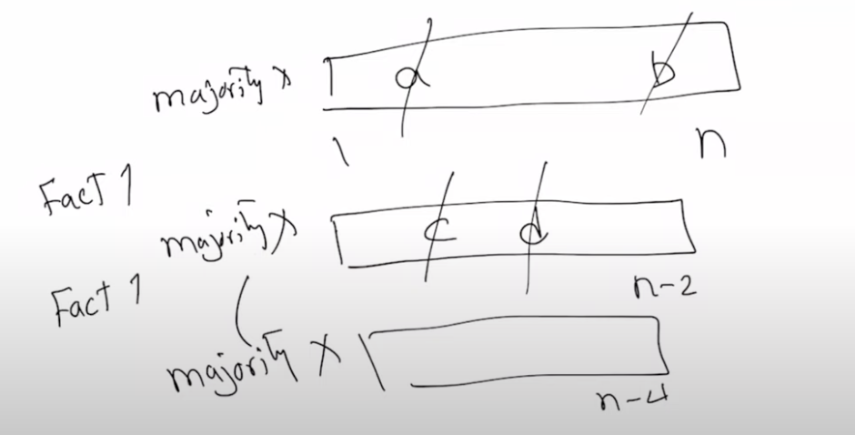
  + How to find the elements to delete?
    - I inititalise the extra storage to the first element and store its count. Then advance the pointer t the next element if non equal, i reinitialise the extra store to ptr->next, and delete the first two. Iterate like this until I reach the end of the list.
      * Whatever’s left after this, is the majority candidate and we can check it’s count. That takes linear time.
    - Time complexity: O(n) (time optimal)

Question: Suppose we have a bunch of numbers positive and negative or zero, I wanna find a set of consecutive elements whose sum is maximized. 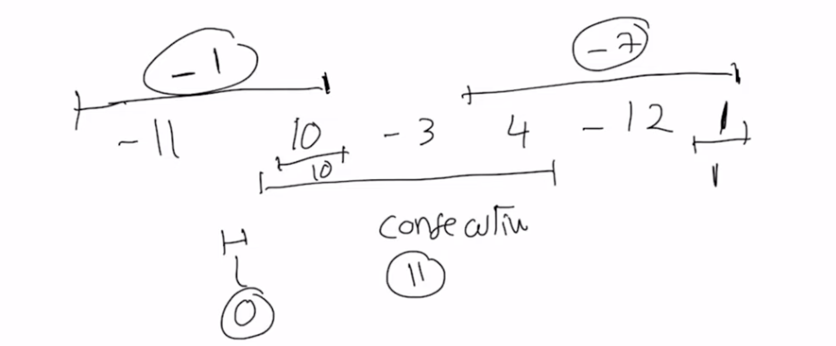

Answer:

* TRIVIAL ALGO Each set of consecutive elements is an interval. Thus, we have n elements and nC2 unique intervals, as I have to pick two endpoints. This takes O(n^2). And then I can do a linear scan in O(n) so I have an algo that runs in O(n^3).
* What we can do is use a dynamic window approach. We can dynamically add, and compare the local to the maximum sum and update accordingly. This will have time complexity O(n).

# 2/7/2024 (W5: Wednesday)

**Divide and Conquer**

* Partition the problem into smaller subproblems.
* Question: We have a set of numbers and we want to put them in a non decreasing order
* Answer:
  + We will partition the problem into problems of smaller size by half, and reach a stage where all the lists have one element.
  + Now we take two lists and merge them into a sorted list. Then we take the next two and merge them into one sorted list. We keep doing this until we reach a size of list n. 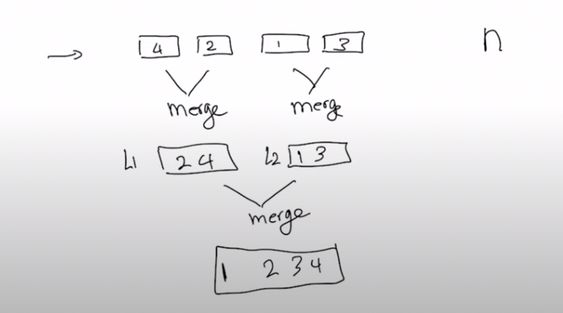
  + **Merging** is the main step:
    - Suppose we have two inputs L and R of size s and t respectively both sorted in non-decreasing order, then we will have an output with size s+t
    - The first element of output ( ${Output}_{1})$ would be min($L_{1}, R_{1})$. Say this is $L_{1}$. Then,
    - The next (${Output}_{2}) = min($ $R_{1}, L_{2})$
    - We can use pointers to advance and track for both the lists L and R. 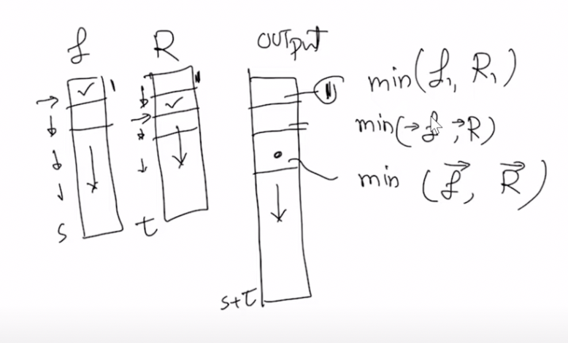
    - Time Complexity: At most I will compare each element of L with every element of R, so O(st).
      * ***BUT***, we see that this is not realistic, so instead of looking at the input, we look at output. Every element in the output came from one comparison, between min( $L_{j}, R_{i}).$ So each output I spent O(1) to get, and we have s+t elements in the output so that means that the runtime is O(s+t)
    - This means that assuming the two lists are sorted, we can merge in linear time!
  + Time complexity:
    - Time to sort one half: T(n/2)
    - Time to sort other half: T(n/2)
    - Time to merge: O(n)
    - 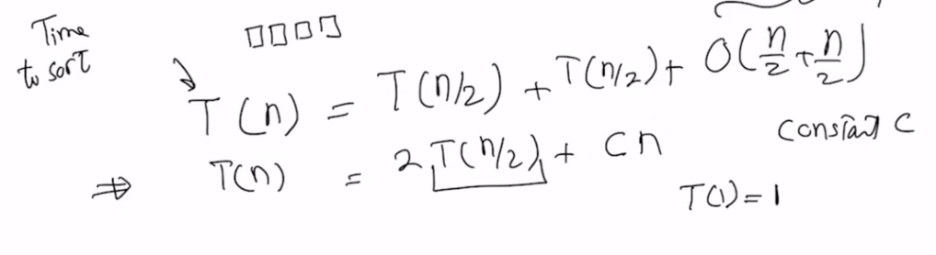
    - We can expand this to the i-th step and we get the equation: 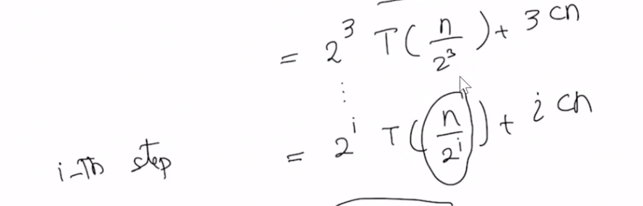
    - 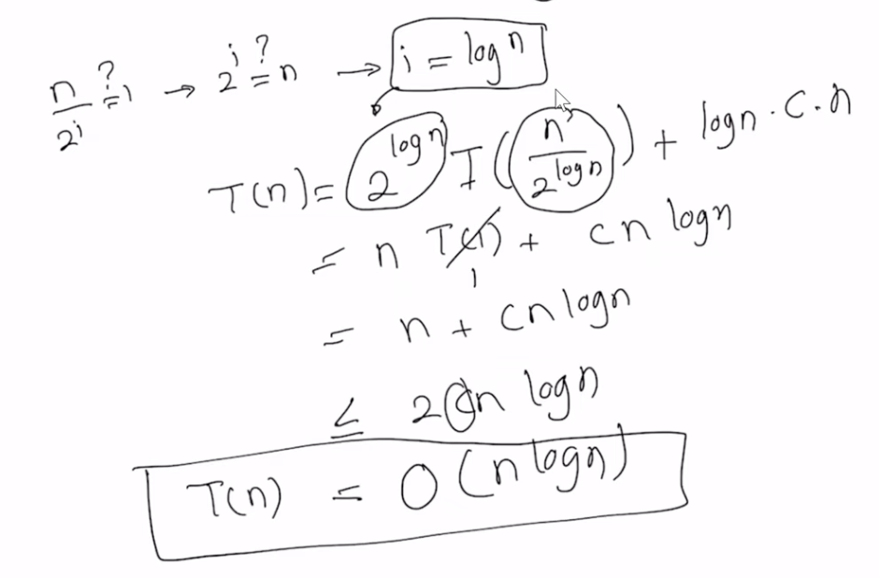
* Question: (INVERSION) We have to count the number of inversions. For the input we have a list and for the output, we want to return an int with the number of inversions.

Minimum number of inversions possible: 0 → sorted list

Maximum number of inversions possible: nC2 → decreasing order list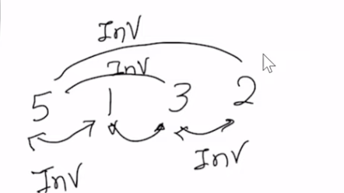

* Answer:
  + Can ***trivially*** get an answer in O(N^2) time by checking all the nC2 pairs.
  + We take the list and divide it into 2 parts, and keep doing that.
  + Suppose we know the count of inversions on the left and on the right, then the total count would be:   
    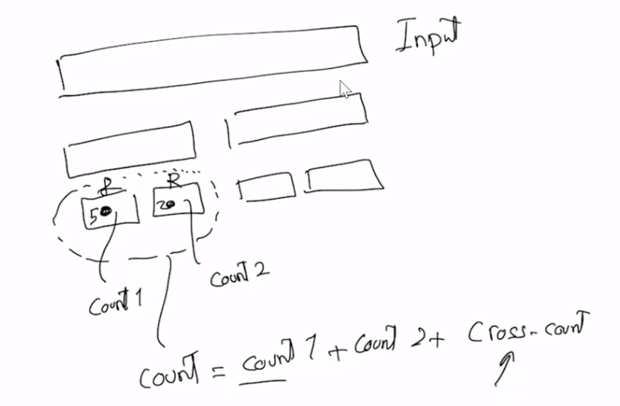
  + Thus, if we through recursion, I know count1 and count2 then all I have to do in the merge step is to calculate the value of cross-count.
  + 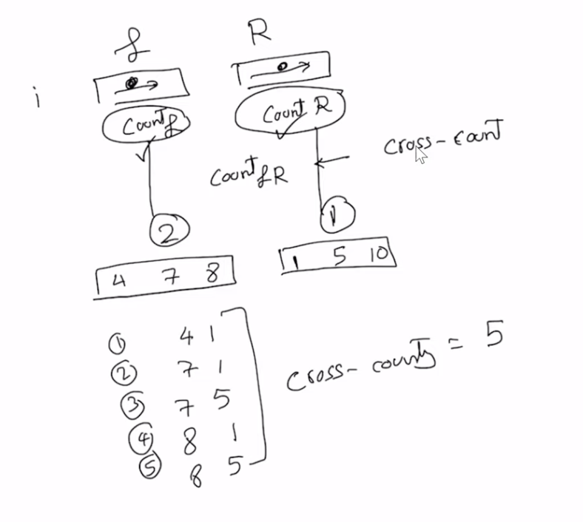
  + **Cross-Count**:
    - We divide the list into two sorted lists.Now if we pick an element from the L it does not contribute to the cross-count. But if we pick an element from the R, then the cross-count is incremented by (s-i). 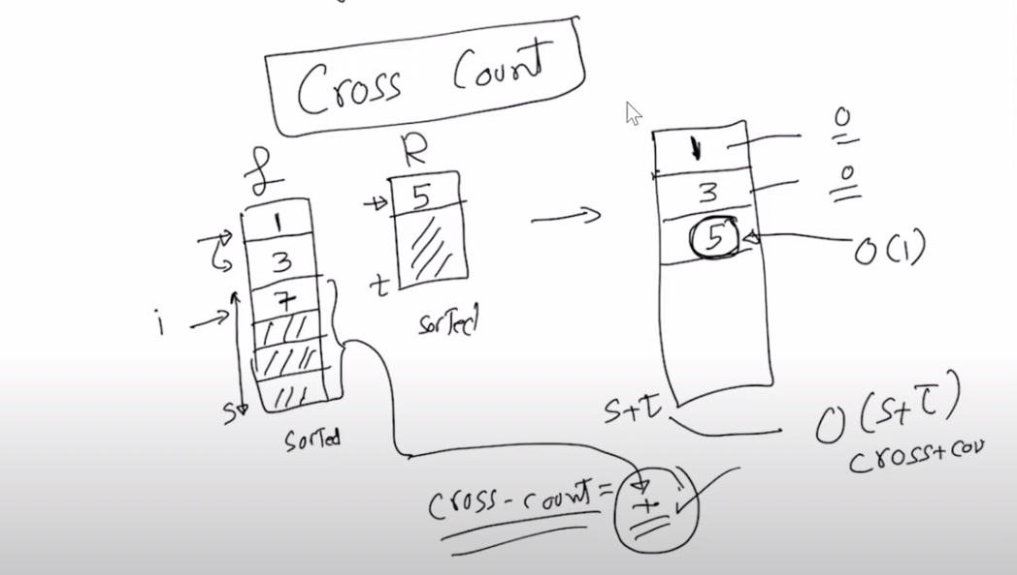
    - Time Complexity: O(s+t)
  + Time complexity for count inversion then is: 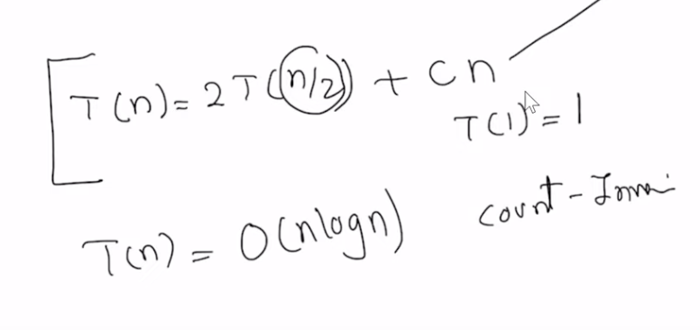
  + To output the pairs is O(N^2)
* Question: (CROSSING PROBLEM) We have two lines separated by a finite distance and there are line segments between them. The line segments are always straight and not curly, wavy or any otehr shape. Two line segments either intersect or don’t. Come up with an algorithm to find the number of crossings. There could be no crossings or a bunch of crossings. 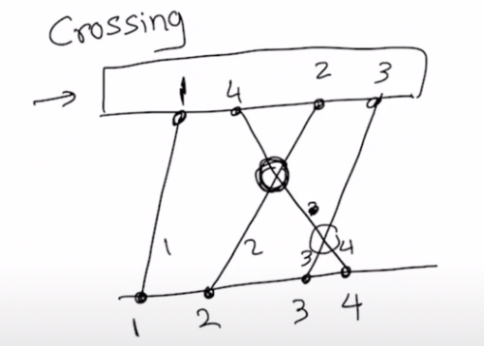
* Answer:
  + Idea: if the top order is reverse of bottom order, the line segments intersect.
  + Identical to counting inversions.
* Question: Suppose we are given a bunch of points and we are to find the points which are reversed like such, then how will we do it? 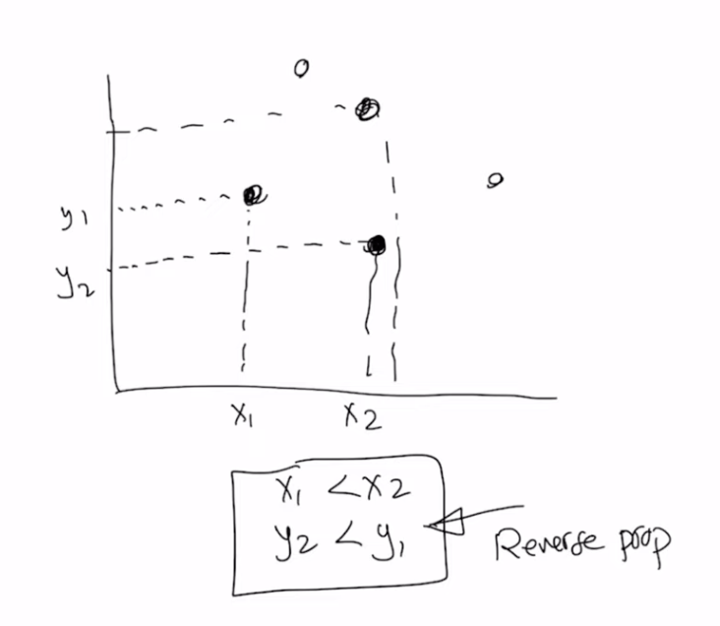
* Answer: Same as inversion problem, number the x coordinates in increasing order, and check for inversion for in y axis, and count inversion.

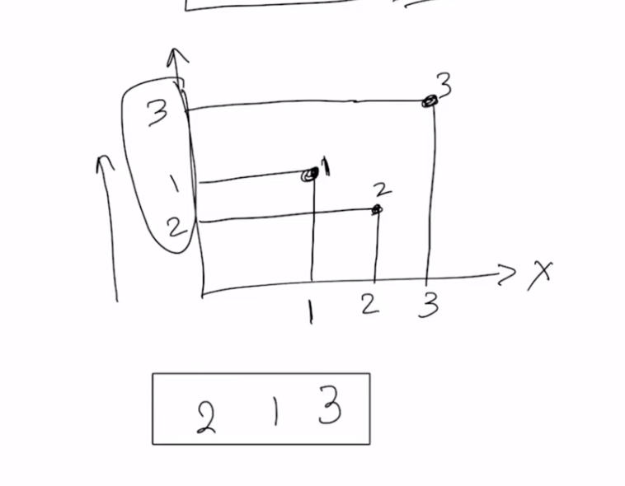

# 2/12/2024 (W6: Monday)

**The Closest Pair Problem**

* If you are given a collection of point sets, which can be in any dimension, we will consider 2D. Find the closest pair of points.   
  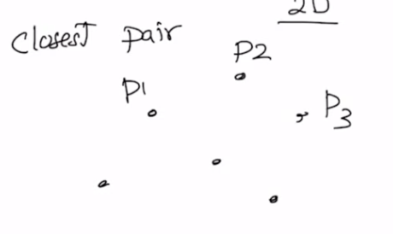  
  We will apply the Euclidean metric to check the distance between two points.
* The computation takes constant time.
* Solution:
  + **(TRIVIAL)** We start by picking an initial solution i.e calculating the distance from p1 to every point: (n-1) + (n-2) …+ 1 → O($n^{2})$. And we can keep track of the minimum values
  + Here we have a point set, say n points, and for each point we have x and y coordinates → 2n values
  + We can start by partitioning the coordinates in any way, either by the x coordinate or the y coordinate
    - If there are points with the same x/y-coordinate and then we can either arbitrarily put in either partition or add a small value e, to make them different
  + 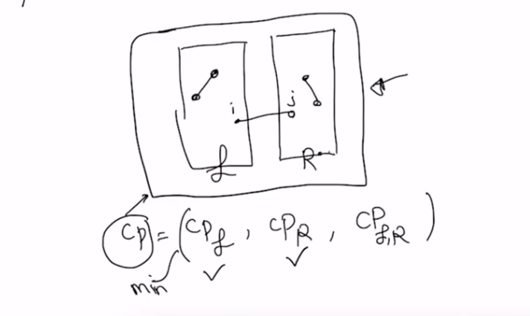  
    Here we assume that we know the CP_L and CP_R.
  + Target runtime:  
    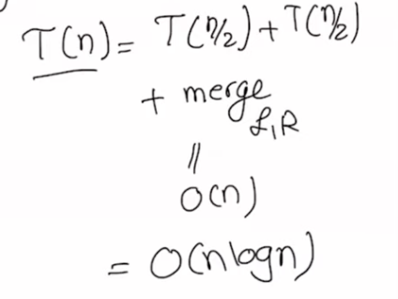  
    So we want to merge in ideally O(n) time.
  + For the merge part: Thus, we have reduced the problem from finding the closest point to finding one point in the L and one in the right that are closest than all other points between L and R
  + Now trivially, if i compare every point on the L to R, then I get: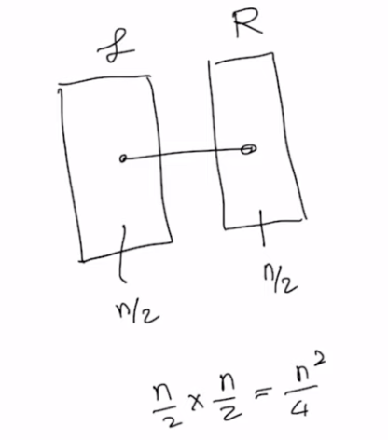 which is the same as O(n^2)
  + The Closest Pair of Points Problem is a classic algorithmic challenge that can be solved efficiently using a divide-and-conquer approach. Here's a step-by-step solution:
  + Step 1: Sort the Points
    - Sort all points according to their x-coordinates (and if two points have the same x-coordinate, sort them according to their y-coordinates). This step is essential for the divide-and-conquer approach and will ensure the points are divided properly.
  + Step 2: Divide
    - Split the sorted array into two halves. This can be done by dividing the list of points into two equal-sized parts by their x-coordinate, creating a left subset ( L ) and a right subset ( R).
  + Step 3: Conquer
    - Recursively find the closest pair of points in the left subset ( L ) and the right subset ( R ). This will give you the smallest distances in each subset, denoted as ( d_L ) and ( d_R ).
    - Let ( d = min(d_L, d_R) ). This distance ( d ) is the smallest pair distance found so far between the two subsets.
  + Step 4: Combine
    - After finding the smallest distances ( d_L ) and ( d_R ), you need to check if there is a closer pair of points with one point in subset ( L ) and the other in subset ( R ). To do this, create a strip that is ( 2d ) wide with the dividing line between ( L ) and ( R ) in the middle.
    - Find all the points that lie within the strip and sort them according to their y-coordinates.
    - Now, for each point in the strip, you only need to check its distance to the next 7 points in the sorted-by-y list. This is because if there were a closer pair, it would have to be within this local neighborhood, according to the "8 squares" heuristic.
  + Step 5: Find the Minimum Distance Across the Strip
    - For each point in the sorted strip list, compute the distance to the next 7 points.
    - If you find a distance smaller than ( d ), update ( d ) with this new distance.
  + Step 6: Return the Result
    - The final answer is the smallest of the distances found between the closest pairs in ( L ) and ( R ) and any closer pairs found in the strip. This distance is the minimum distance between any pair of points in the original set.
  + Complexity
    - The sorting steps at the beginning and when sorting the strip are ( O(n log n) ).
    - The recursive division is ( O(log n) ) since it's a typical divide-and-conquer.
    - The combination step, due to the "8 squares" heuristic, is ( O(n) ) for each level of recursion.
    - The overall complexity of the algorithm is therefore ( O(n log n) ), which is much more efficient than the brute force approach with ( O(n^2) ) complexity.

# 2/21/2024

**Dynamic Programming**

* Break the problem into subproblems and use recursion to either build a top down solution or a bottom up solution.

**Weighted Interval Problem**

We have weighted intervals and we want to find the maximum weight for non overlapping intervals.

* Step 1: Sort the Jobs
  + Sort the jobs by their finish times so that f1 <= f2 <= f3 <= ... <= fn.
* Step 2: Compute the Previous Non-Overlapping Job Index
  + For each job j, find the rightmost job i that does not overlap with j. Let's call this p(j).
  + This can be done efficiently by either a linear search from job j-1 backwards or using binary search for larger datasets.
* Step 3: Create a Table for Dynamic Programming
  + Initialize a DP table M where M[j] will hold the maximum weight for the first j jobs.
  + Set M[0] to 0 because if there are no jobs, the maximum weight is 0.
* Step 4: Populate the DP Table
  + For each job j from 1 to n, do the following:
    - Find the weight w(j) of the current job j plus the maximum weight of all the jobs that finish before the current job starts, which is M[p(j)].
    - Set M[j] to the maximum of M[j-1] (the maximum weight without taking job j) and w(j) + M[p(j)] (the maximum weight when taking job j).
    - In other words, M[j] = max(M[j-1], w(j) + M[p(j)]).
* Step 5: Reconstruct the Solution
  + Start from M[n] and backtrack to find which jobs were included in the maximum weight set.
  + If M[j] is equal to M[j-1], job j was not included. If M[j] is greater than M[j-1], then job j was included, and we should move to M[p(j)] to continue the reconstruction.
* Step 6: Return the Result
  + M[n] contains the maximum weight that can be obtained without overlapping jobs.
* Time Complexity:
  + Sorting the Jobs: O(nlogn), where
  + Finding the Previous Non-Overlapping Job: The computation of the previous non-overlapping job index p(j) for each job can be done using a linear search resulting in O(nlogn) using binary search.
  + Populating the DP Table: Once the p array is computed, filling the DP table takes O(n) time, since each entry M[j] requires only constant time operations based on previously computed values.
  + Reconstructing the Solution: The reconstruction of the solution from the DP table can also be done in O(n) time by backtracking through the table.
  + Adding these parts together, the dominant term is the initial sorting of the jobs and the binary search for computing the p array. Therefore, the overall time complexity of the weighted interval scheduling algorithm using dynamic programming is:
    - O(nlogn)+O(nlogn)+O(n)+O(n)=O(nlogn)

**Knapsack Problem**

* Initialize the DP Table: Create a table dp with dimensions (n+1) x (W+1) where n is the number of items and W is the total capacity of the knapsack. Initialize all values to 0.
* Fill the DP Table: Iterate through the table filling in values according to the formula:
  + dp[i][w] = max(dp[i-1][w], dp[i-1][w - weight[i]] + value[i])
  + where i is the current item index, and w is the current weight capacity being considered. The formula essentially states that the maximum value for dp[i][w] is the higher of:
    - The value we get by not taking the current item (which is the same as the maximum value we could get for all items up to i-1 with the same weight limit w), and
    - The value we get by taking the current item (which is the value of the item plus the maximum value we could get for all items up to i-1 with a weight limit reduced by the weight of the current item).
* Find the Maximum Value: The maximum value that can be carried by the knapsack is found at dp[n][W].
* Reconstruct the Items Taken: To find which items to take, you start from dp[n][W] and work your way backwards through the table, checking if the value came from taking the current item or not.
* Time Complexity
  + The time complexity for the 0/1 Knapsack problem using dynamic programming is O(nW), where n is the number of items and W is the maximum weight capacity of the knapsack. This is because you need to fill in a table of n items for each possible weight increment up to W.
  + Pseudo polynomial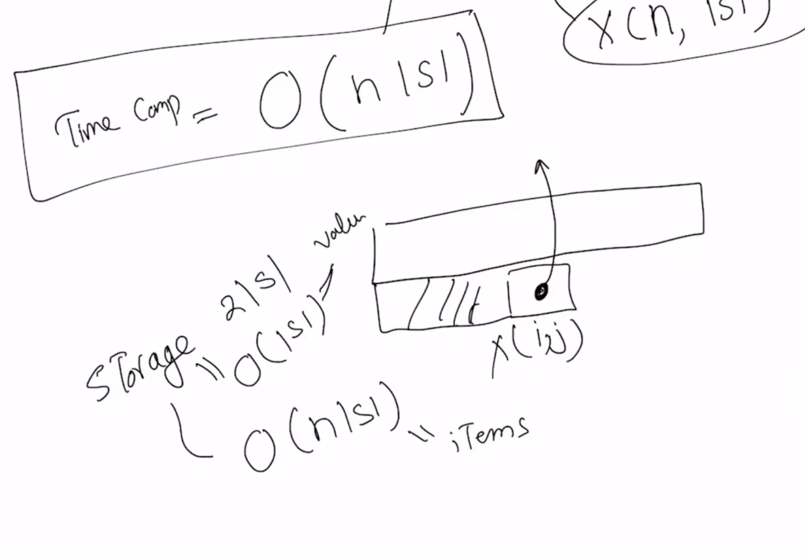

# 2/26/2024

**Sequence Alignment**

Given two sequences from the english alphabet. They don’t have to be of the same length. For example: s1 = bcdabcd (size: m) and s2 = abcd (size: n). Input size: m+n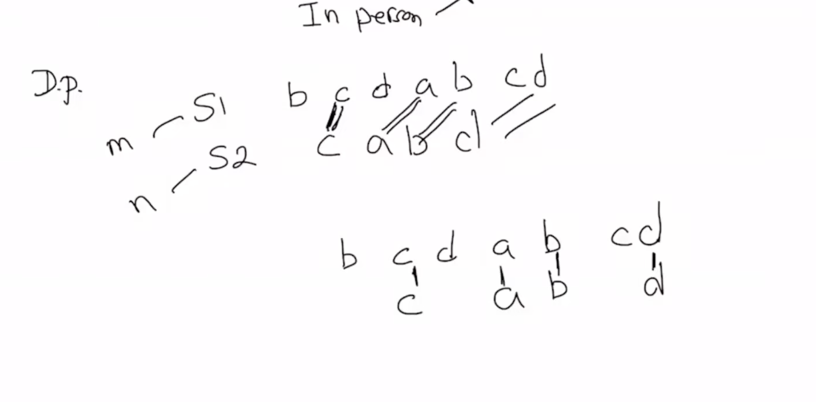

Longest common subsequence  
 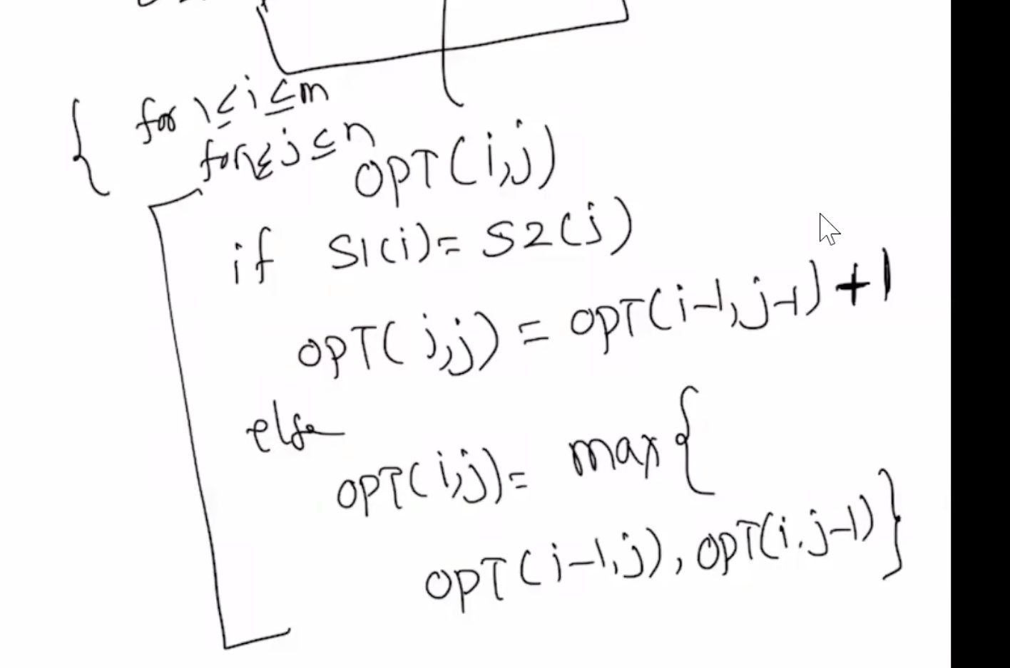

* Step 1: Create a Table
  + Suppose you have two strings X and Y, and their lengths are m and n, respectively.
  + Create a DP table dp of size (m+1) x (n+1) to store the lengths of LCS. The reason for m+1 and n+1 is to have a default initialized row and column of 0s, which simplifies the logic when dealing with the first row or first column.
* Step 2: Initialize the Table
  + Initialize all cells of the first row and the first column to 0, which represents the length of the LCS when one of the strings is of length 0 (there can’t be a common subsequence).
* Step 3: Fill the Table
  + Fill the DP table using the following logic:
    - If X[i] == Y[j], set dp[i][j] = dp[i-1][j-1] + 1. This represents the case where the current characters match, so the LCS length increases by 1.
    - If X[i] != Y[j], set dp[i][j] = max(dp[i-1][j], dp[i][j-1]). This represents the case where the current characters don’t match, so the LCS length is the maximum of the lengths we get by either skipping the current character of X or the current character of Y.
* Step 4: Traverse the Table
  + Start from dp[m][n] and move backwards through the table to reconstruct the LCS.
    - If X[i] == Y[j], this character is part of the LCS. Add it to the LCS string and move diagonally up to dp[i-1][j-1].
    - If X[i] != Y[j], move in the direction of the larger of the two adjacent cells (dp[i-1][j] or dp[i][j-1]). This move essentially skips the character(s) not included in the LCS.
* Step 5: Return the Result
  + The length of the LCS is contained in dp[m][n].
  + The actual LCS can be constructed by backtracking as described in step 4.
* Time Complexity
  + The time complexity for solving the LCS problem using dynamic programming is O(mn), where m is the length of string X and n is the length of string Y. This is due to the fact that each cell of the dp table needs to be filled in, and each cell requires constant time operations.

**RNA Matching problem   
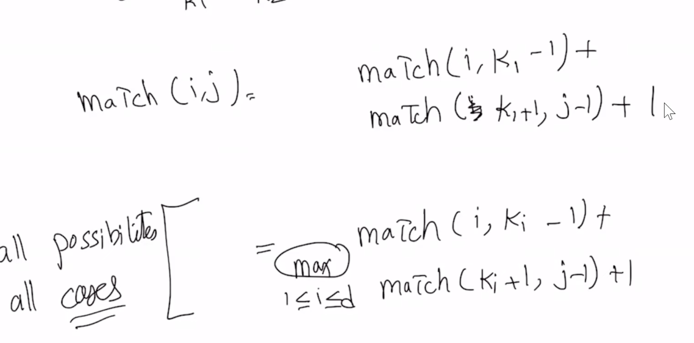**

* Initialization: Initialize a 2D array DP with dimensions n x n, where n is the length of the RNA sequence. Initially, all elements are set to 0, since the maximum number of pairings in a sequence of length 0 or 1 is 0.
* Fill DP Table: The DP table is filled in a bottom-up manner. For each subsequence length L from 2 to n (inclusive), and for each starting index i, calculate the ending index j = i + L - 1. Then, compute DP[i][j] using the following rules:
  + If S[i] and S[j] can form a pair, check if adding this pair to the optimal solution of the subsequence S[i+1...j-1] (i.e., DP[i+1][j-1] + 1) is beneficial.
  + For each possible division k in the subsequence S[i...j], where i ≤ k < j, check if splitting the sequence into two parts, S[i...k] and S[k+1...j], increases the number of pairings. Hence, for each k, compare the current DP[i][j] with DP[i][k] + DP[k+1][j] and update DP[i][j] with the maximum value obtained.
  + The final decision for DP[i][j] is the maximum number of pairings obtained from either pairing S[i] with S[j] or splitting the sequence at some k.
* Iterate Over Subsequence Lengths and Starting Points:
  + For L from 2 to n, and for each starting index i, where 1 ≤ i ≤ n-L+1, compute j = i+L-1 and then update DP[i][j] as described.
* Final Solution:
  + The solution to the problem, i.e., the maximum number of non-crossing pairs, will be stored in DP[1][n], covering the entire sequence.

# 2/28/2024

**Shortest Path Problem with Negative Weights**

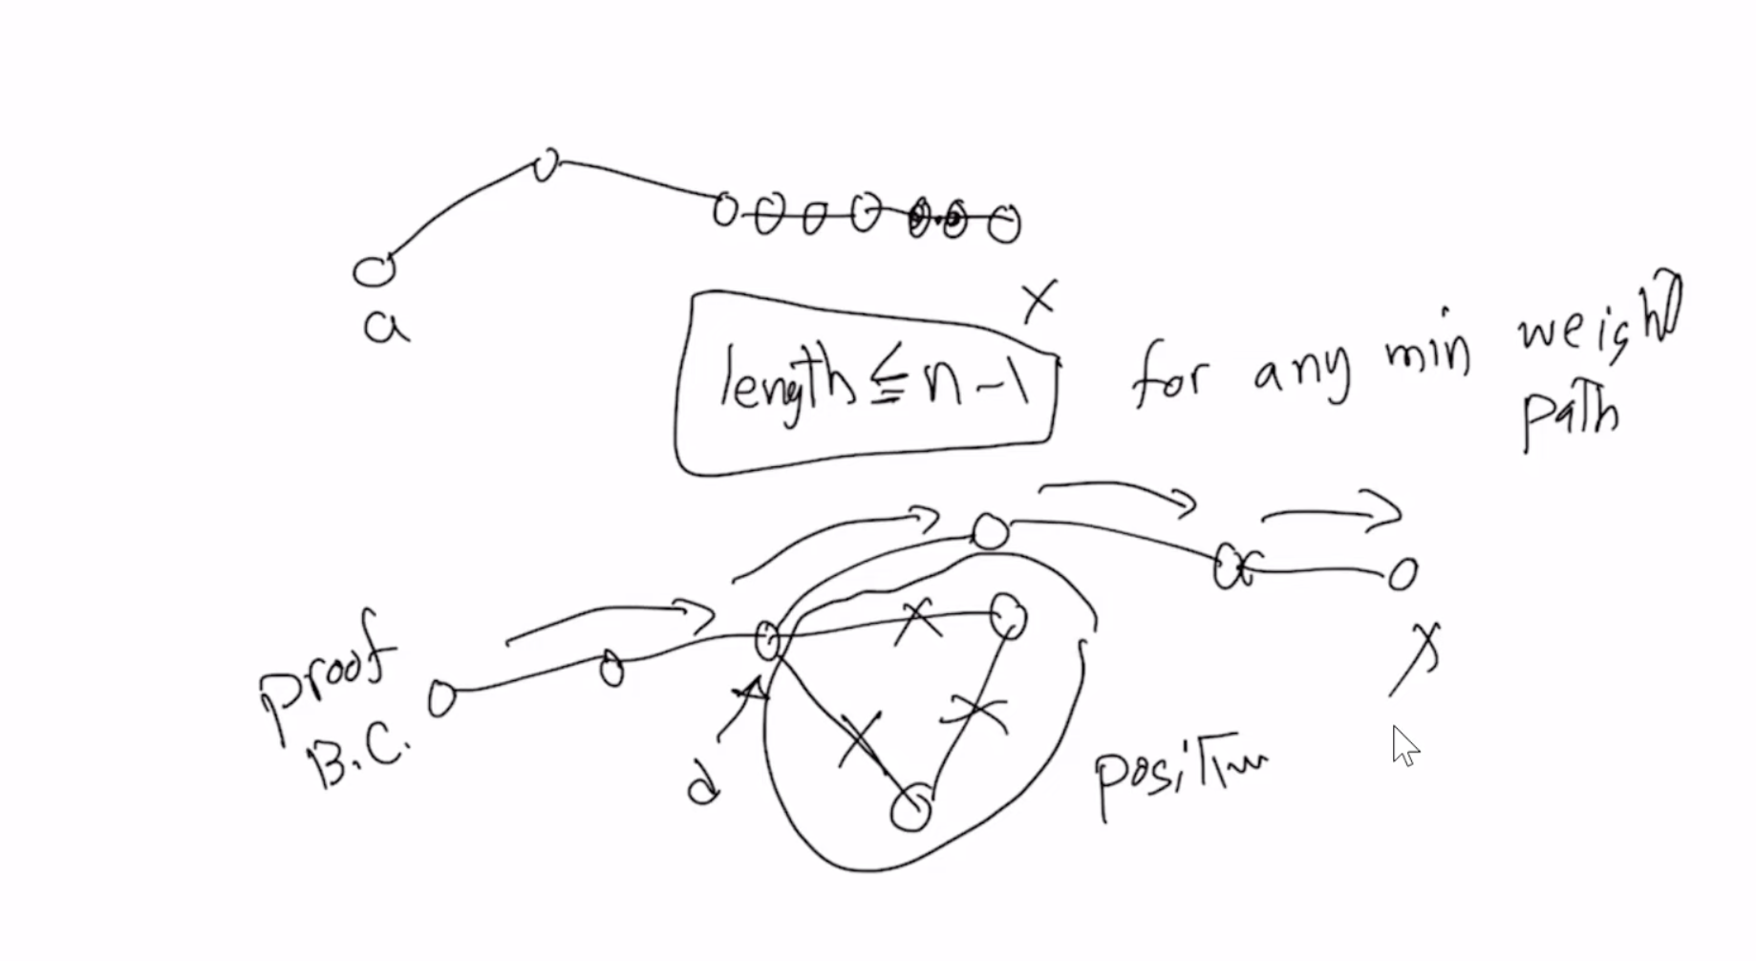

Algorithm cannot handle negative cycle as that would mean that the algorithm will loop in the cycle

The maximum number of edges can be n-1, as anything more means going through an edge more than once to the get the minimum weight which would imply negative cycle

* Step 1: Initialize the Distance Matrix
  + Create a matrix dist, where dist[i][j] represents the shortest distance from vertex i to vertex j. Initially, dist[i][j] is set to Infinity for all pairs of vertices except when i = j, for which dist[i][j] = 0.
  + For each edge (u, v) with weight w in the graph, set dist[u][v] = w to reflect the direct path from u to v.
* Step 2: Dynamic Programming Update
  + For each vertex k, consider it as an intermediate vertex in the path from i to j for all pairs of vertices (i, j).
  + Update the dist[i][j] to reflect the minimum of its current value and the sum of dist[i][k] and dist[k][j], which represents the path from i to j passing through k.
  + This is expressed as: dist[i][j] = min(dist[i][j], dist[i][k] + dist[k][j]).
* Step 3: Detecting Negative Cycles
  + After completing the updates for all vertices, run through the dist matrix one more time. If you find that dist[i][i] < 0 for any vertex i, it indicates the presence of a negative cycle reachable from i.
* Complexity and Usage
* Runtime Complexity: The triple nested loops lead to an O(n^3)

if there's no change in the weights between iterations

*Wi*−1 and *Wi*: Yes, you can indeed terminate the algorithm early if, during an iteration over all edges, no distance is updated. This optimization can significantly improve the practical runtime, especially for graphs where the optimal distances are reached well before *V*−1 iterations.

# 3/4/2024

**Network Flow Problem**

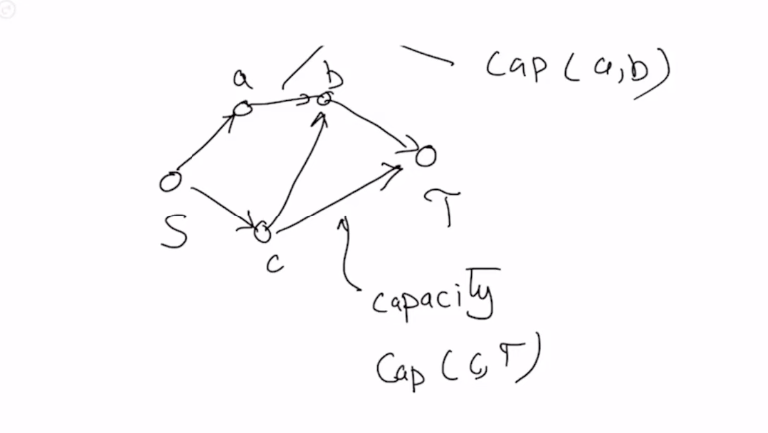

* Rules:
  + c(e) >= 0
  + 0 <= f(e) <= c(e)
  + Conservation of flow → as much coming in to an edge == going out of edge, except for vertices S and T
* When we have a saturated edge i.e. f(e) = c(e) → I remove the saturated edge
* We want to maximize the flow → always find the shortest path (greedy+change our mind later)
  + Because greedy rn can give us either X or Y, and we want X:  
    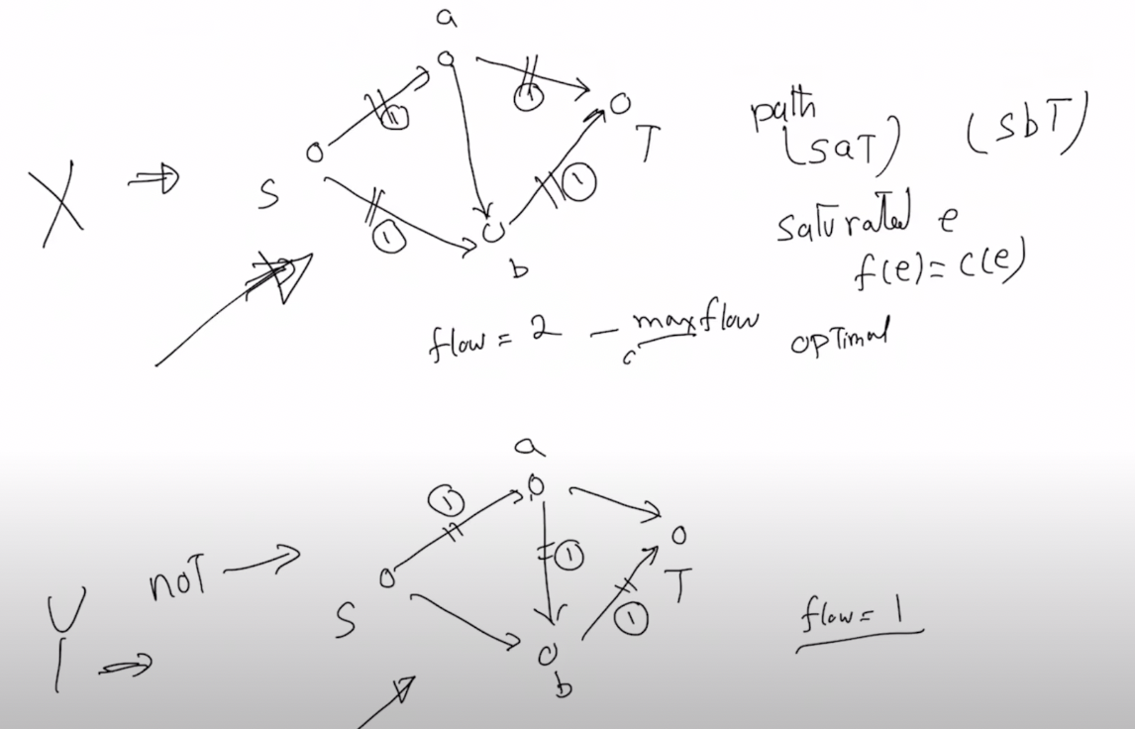
  + How do we do this? We create a residual network which is the original network+backedges  
    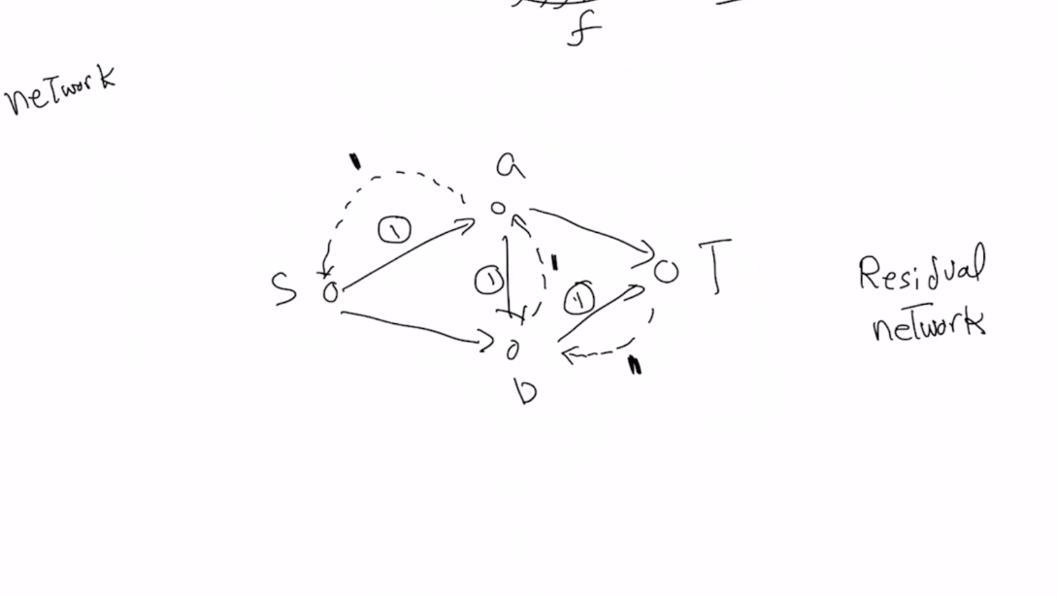
  + The capacity on the backedge is always equal to the flow on the forward edge
  + To go about solving this problem:   
    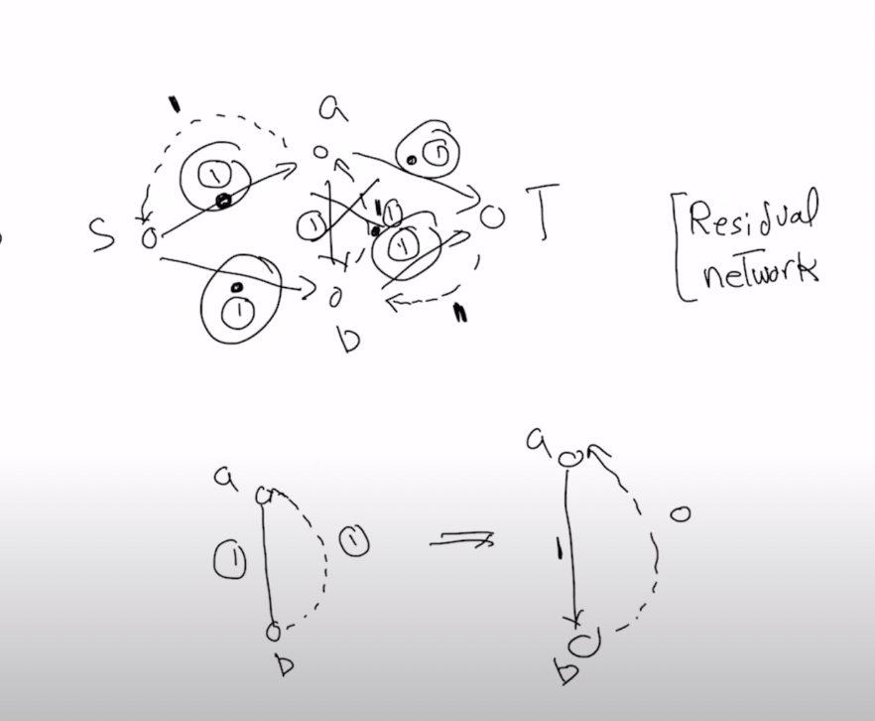  
    Suppose our greedy algorithm gets edge SABT. We add backedges to all the SABT proportional to the flow. Now do we have a path from S to T with open capacity? Yes! The path is utilizing the backedge BA. Thus the path is SBAT. Now, the backedge flow will cancel out with the front flow in the edge AB, and the front flow of AB will be f(e) - backedge flow
  + 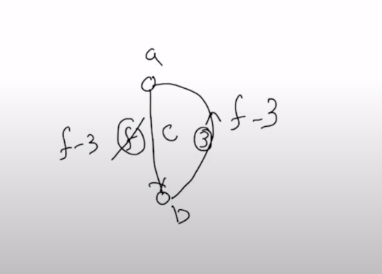
* New Algorithm **(Ford-Fulkerson)**:
  + Start with a network N
  + Find a path, and send one unit of flow along the path
  + Build residual network, and set their capacities to 1
    - Using localized transformation technique
  + Find another path, in the new residual network and build a new residual network 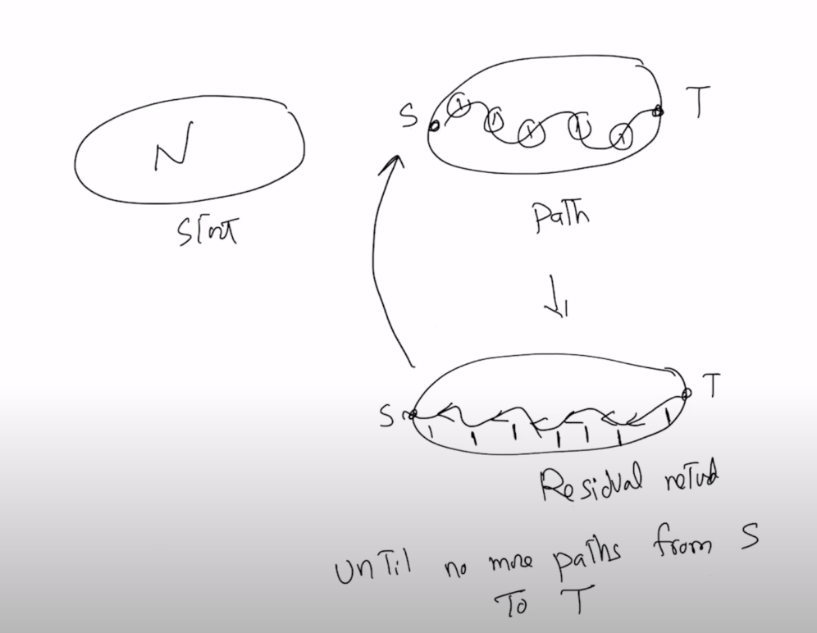

Cut: Bipartition of edges

Capacity of the cut: edge addition between L and R  
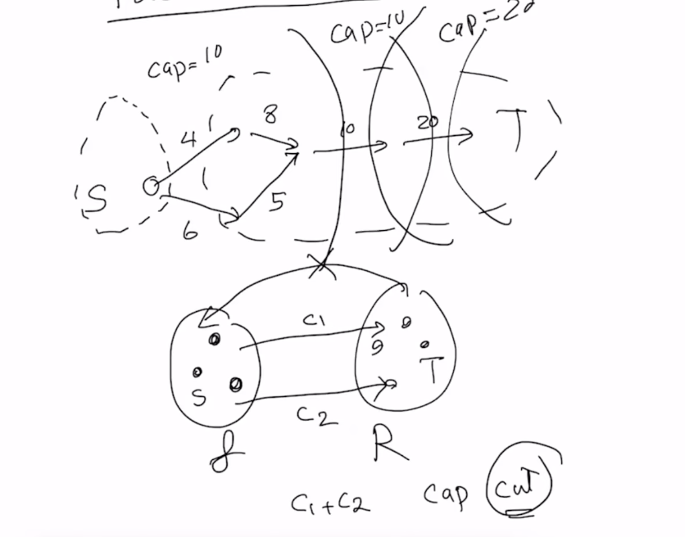

* For this network N what is the maximum flow?  
  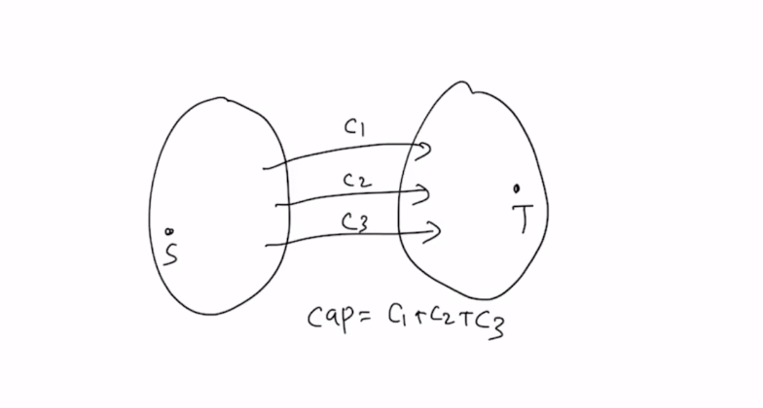
  + What leaves S and reaches T
  + Max flow < cap_j for any cut j

Equivalent statements

* If some kind of flow is a max flow in G/N
* The residual network G(f) no augmenting paths i.e. no paths from S to T (FF Algo stopping criteria)
* f = c(S,T) for some cut C in G

Proving that these statements are equivalent:

* 1 → 2  
  If f is max flow, and there exists an aug path in G then that means i can send at least one more unit of flow, which means f+1 but then that’s contradictory because f is maxflow by 1. 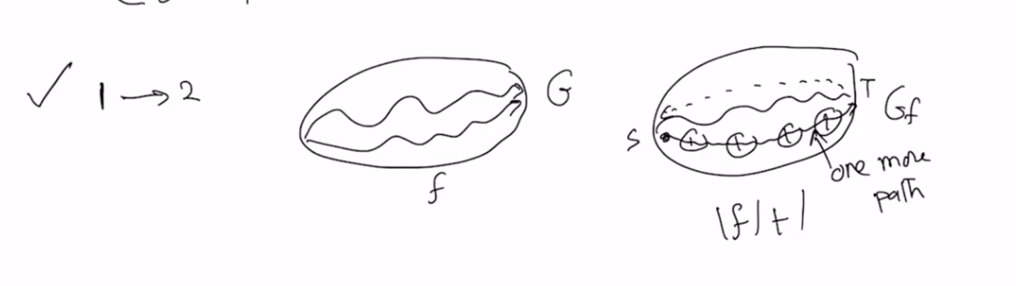
* 2 → 3  
  Suppose I have a network and lets say i remove all saturated edges, must disconnect the graph as no aug edges. And put S in the left partition. Now as there is no augmented path that means that i can only go from S to T using saturated edges. Thus, f = c(ST)  
  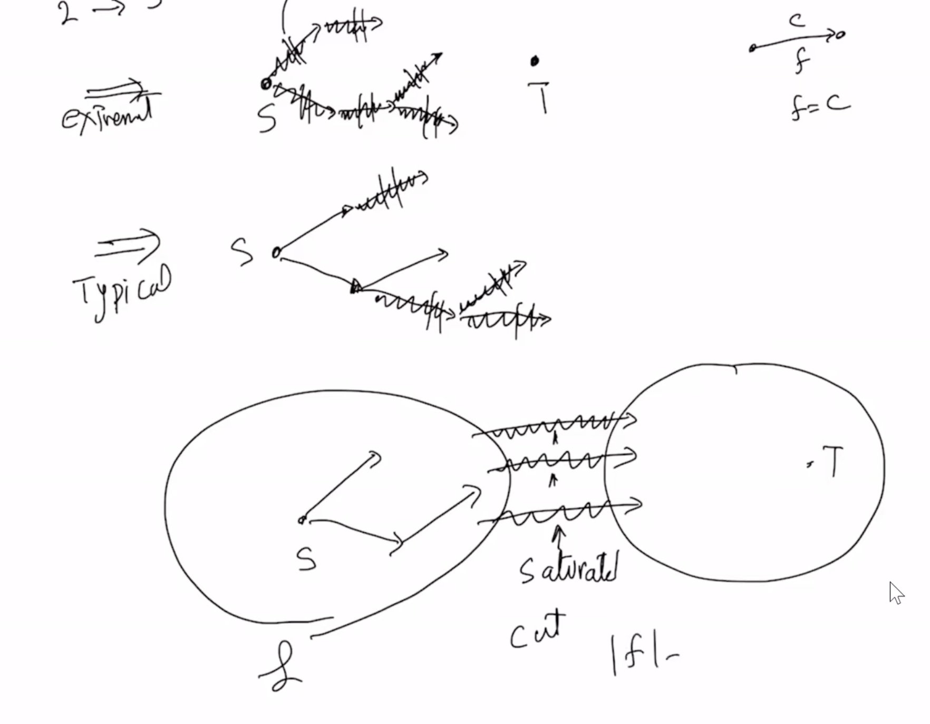
* 3→1

f = c(ST) → f is maxflow

For any cut f <= cap. Now by 3 we have shown that there is a cut with f = cap, which means it must be maxflow

# 3/6/2024

Time Complexity of FF:

* If the network has n vertices and e edges → residual network(n, 2e (at max))
* To find an aug path in the residual network: O(n+2e) => O(n+e)
* As for each unit of flow, we spend n+e time → total runtime = O(|f|(n+e)) **(Basic version)**
* **It is pseudo polynomial**

**Design Problems**

**Cellphone Assignment Problem:**

* Suppose you have a telecommunication tower network. How do we do this efficiently?
  + The cap of a tower <= C
    - Say max 500 cellphones can be assigned to a tower
  + A cell phone can be connected to a tower if the distance from the tower is less than some distance r.
* Solution:
* (Not working) sort the distances, apply greedy, does not always work
* Create a bipartite graph with cellphones on one side and towers on the other, and create directed edges with possible connections like so:   
  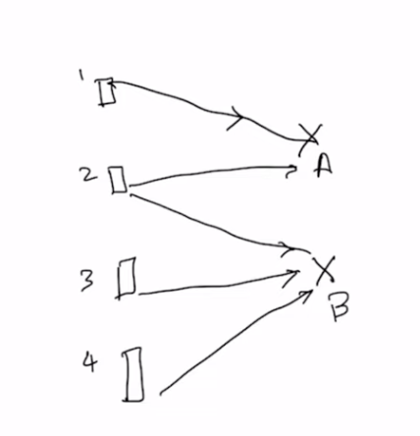
* So far this is only for design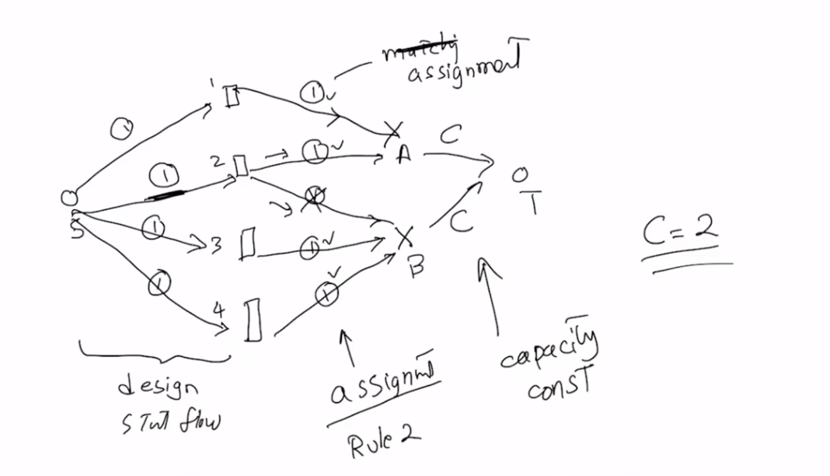
* If capacity of each tower is different then we will use C_a and C_b and it will still work
* If we have like cell phone strength so that one cell phone i solder and needs to be connected to a closer tower, and one to a further away tower then, we can take that into account in the assignment
* **If I have n cellphones, and |f|<n then I have no solution.**
* **When |f| = n → there is a solution**
* **If |f| > n → error**

**Bipartite Problem**

Solving the bipartite matching problem with a greedy algorithm might seem straightforward at first glance: you could try to match each vertex from one set to an available vertex in the other set, picking any available match you come across. However, the main issue with a greedy approach is that it can easily lead to suboptimal solutions. This is because early greedy choices might block off paths to better matches later on, potentially reducing the overall size of the matching you end up with.

Why Greedy Algorithms May Fail

Let's consider a simple bipartite graph example to illustrate why a greedy algorithm might fail:

Set A: Vertices A1, A2

Set B: Vertices B1, B2

Edges: (A1, B1), (A1, B2), (A2, B2)

A greedy approach might match A1 to B1 because it sees an available match. Then, A2 can only be matched to B2. This results in a total of 2 matches, which is actually the maximum for this simple case. However, if there were more vertices and more complex connections, and the greedy algorithm matched A1 to B2 first (assuming some arbitrary rule or order), it might leave A2 without a match if there were no direct edge to B1, potentially missing out on optimal pairings available.

Why Ford-Fulkerson Works

The Ford-Fulkerson algorithm, applied through the construction of a flow network from the bipartite graph, systematically explores all possibilities to ensure that the maximum matching is found:

Constructing a Flow Network: Convert the bipartite graph into a flow network by adding a source vertex connected to all vertices in set A, and a sink vertex connected to all vertices in set B. Set the capacity of all edges to 1 to represent the one-to-one nature of bipartite matchings.

Finding Augmenting Paths: Ford-Fulkerson then finds augmenting paths from the source to the sink. Each path represents a potential matching. By respecting the capacities (which are set to 1), the algorithm ensures that no vertex is matched more than once.

Adjusting for Maximum Flow/Matching: The algorithm adjusts the matches (flow) based on these augmenting paths, ensuring that every match is as optimal as possible within the constraints of the bipartite graph. This adjustment process allows Ford-Fulkerson to backtrack if necessary, unlike greedy algorithms, which lack this flexibility.

Termination: The process repeats until no more augmenting paths can be found, ensuring that the maximum matching has been achieved.

**FF is just greedy but I can also work backwards → more adaptable.**

# 3/11/2024

**Traveling Salesman Problem**

Visit all nodes and minimize d.

**Transformability**

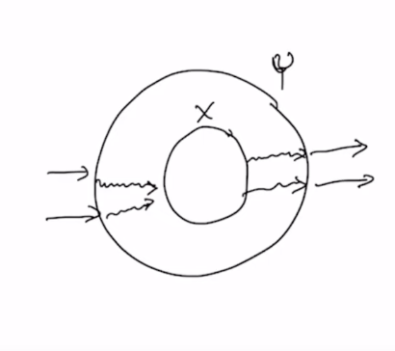

* Y is polynomial time transformable to X  
  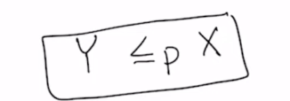
  + P here stands for polynomial time. There could be L, which would be linear time.
* FACT 1:  
  

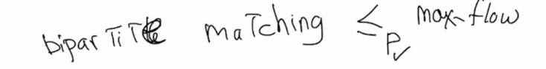

* FACT 2:

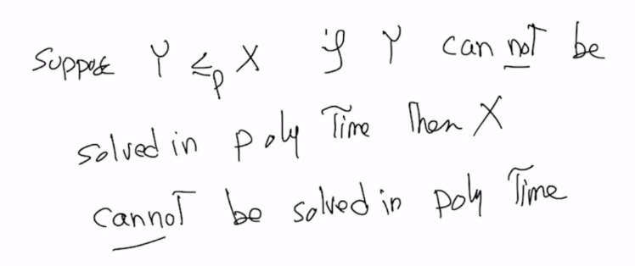

**Max Clique Problem**: Find the max clique in a graph

* Can easily solve the problem but not in polynomial time.

**Max Independent Set:**

* Pairwise not connected. Find the largest such set.

I want to show that max clique problem is polynomial time transformable to max independent set problem.

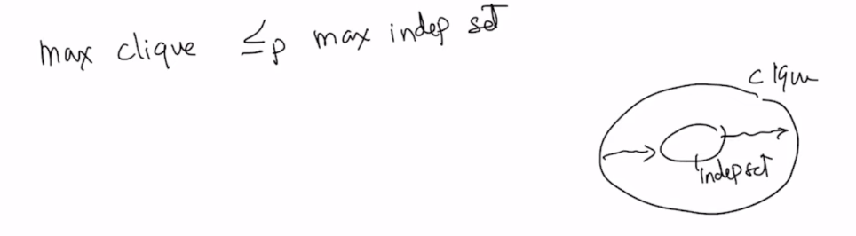

Let’s start with an arbitrary instance of max clique. I can then create a complement graph and getting the max independent set from that → max clique in the original graph. I can transform this in O(n^2) time as that is the max amount of time it takes to create n edges. Thus, i have shown that the max independent set problem is polynomial time tranformable to max clique set.

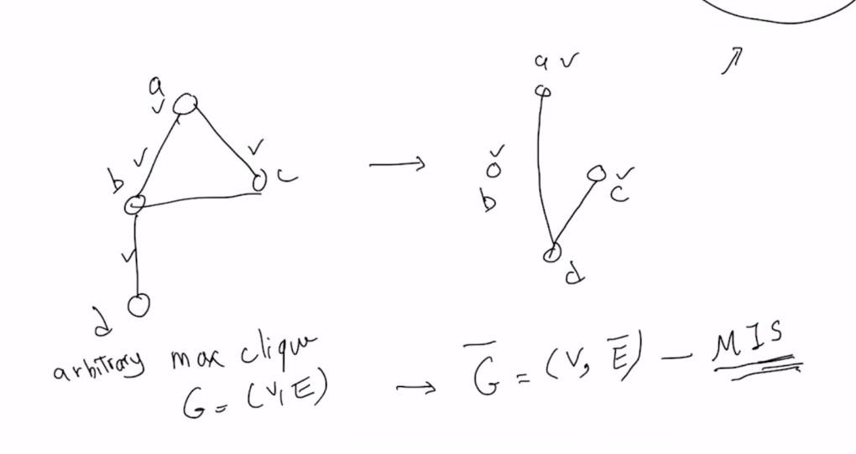

NP-Complete problems: not solvable problems in polynomial time. If given a problem, transform it into a known NP-C problem and then say that it cannot be solved!

**Minimum vertex cover**

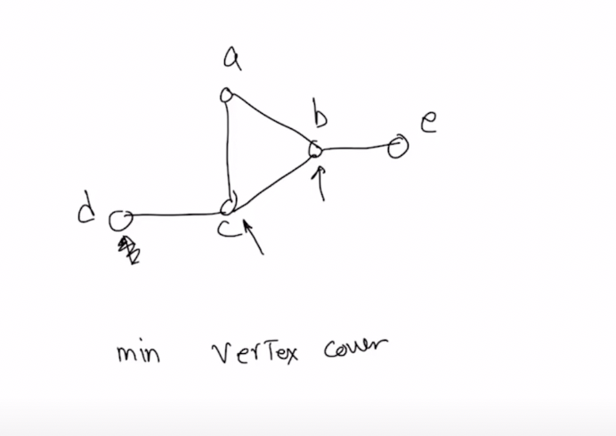

A vertex cover is so that it touches all the edges. Here it is c, b.

Minimum Vertex Cover to Maximum Independent Set: Given a graph *G*, its complement graph Gˉ is a graph on the same vertices where two vertices are adjacent in Gˉ if and only if they are not adjacent in *G*. The complement of a minimum vertex cover in *G* is a maximum independent set in *G* and vice versa. This is because if a set of vertices covers all edges, the remaining vertices do not have any edges among them, making them an independent set.